Neuropathology Case 3

Children’s Hospital Conference
Friday April 28, 2017

3 year-old girl with recurrent tumor

Presentation July 2015
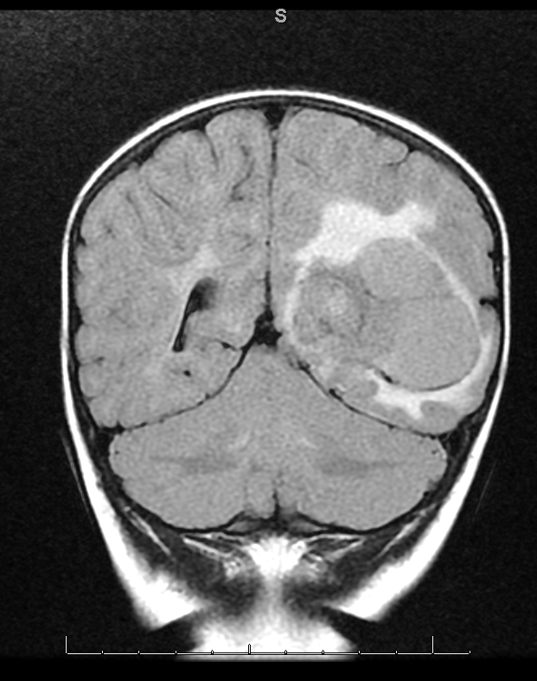 gross total resection.

recurrence March 2017

No intraoperative consultation was requested.

H&E stained slide.

1. What is your differential diagnosis?
2. What immunostains would be the most important?
3. What molecular studies are needed for this kind of tumor to confirm the diagnosis?

NP case 3 – answer

A large hemispheric, non-infiltrating tumor with contrast enhancement in a 3-year-old child could be a pilocytic astrocytoma, glioblastoma, atypical teratoid/rhabdoid tumor (ATRT), anaplastic ependymoma, choroid plexus carcinoma (CPC) and poorly differentiated High Grade Glioma (HGG) or Malignant neuroepithelial (NE) tumor/Embryonal tumor (previously called PNET). In this case the MRI scans showed an association with the ventricle.

2. INI-1 – to rule out ATRT
GFAP should be strongly staining in a GBM, pilocytic and anaplastic ependymoma, negative in the CPC, a little or patchy staining in the less differentiated NE tumors.
Ki67 proliferation
other stains that might be useful:
transthyretin [aka, pre-albumin] (positive in CPC, not others)
cytokeratin – often patchy positive staining in CPC and ATRT, but CPC usually have more staining and clearly membranous.
e-cadherin and CD56 – if considering a papillary ependymoma vs a CPC: CPC usually have strong e-cadherin membranous staining (negative in ependymoma) and CPCs lack CD56 staining (strongly positive in ependymoma).
p53 – most CPC have a p53 mutation and show strong nuclear staining.

3. CPC are only associated with TP53 mutations, which do not affect prognosis in non-Li Fraumeni cases. If immunostains are ambiguous molecular studies can be useful in confirming the absence of other identifying mutations.

