Neuropathology Case 1

Children’s Hospital Conference
Friday April 28, 2017

3 year-old male presenting with atypical facial pain was found to have a brainstem lesion extending from inferior pons and middle cerebellar peduncle to the inferior medulla. An open biopsy was performed and submitted for intraoperative consultation.
[Review slide].

What is the differential diagnosis?
What will you tell the surgeon after evaluating the smear?

[review H&E paraffin section]

What is the most likely diagnosis and how would you confirm it?

Contrast enhancing scan
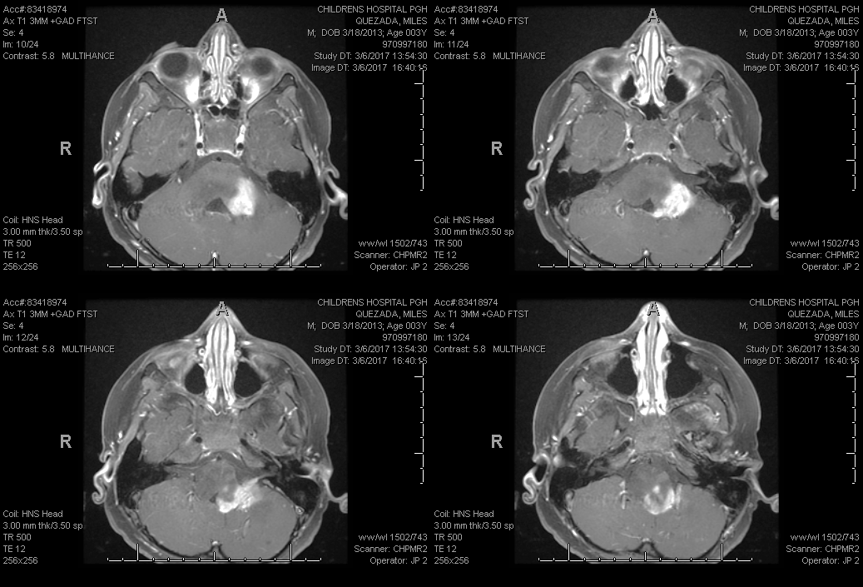

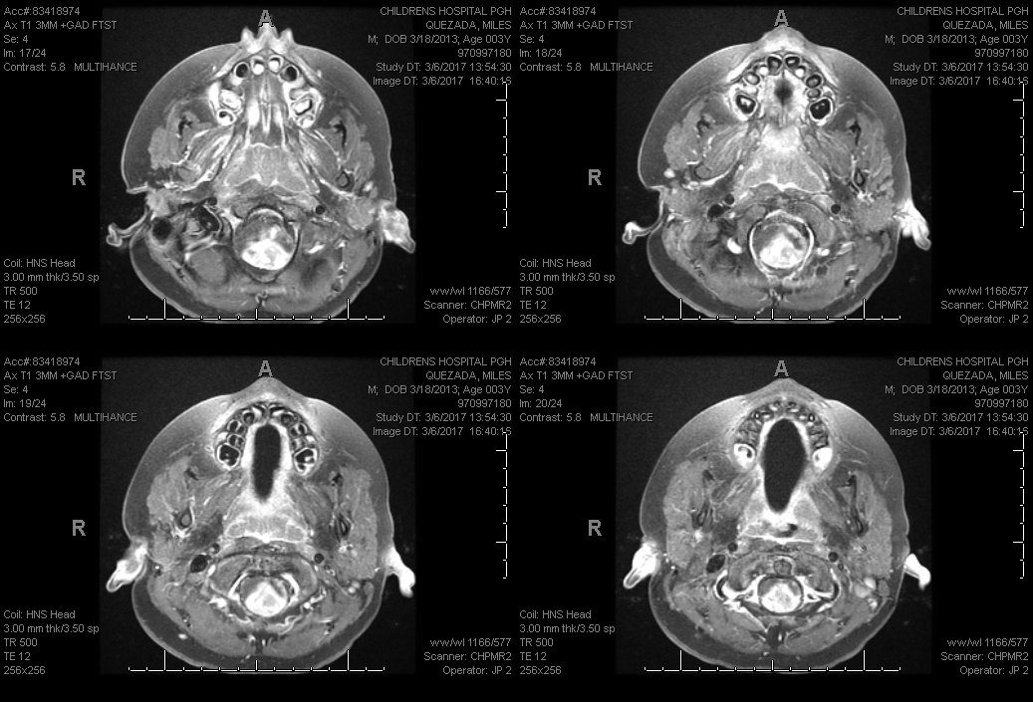

Answers: Case 1 4/28/17
1. The most common differential diagnosis for a posterior fossa tumor in a child is: medulloblastoma, ependymoma, or pilocytic astrocytoma. The possibility of a Diffuse Intrinsic Pontine Glioma was also considered. It is unusual for any of the above tumors to have such extensive involvement of the medulla.

2. As always, you tell the surgeon what they need to know – in this case, an adequate biopsy was the goal of the surgery. Review of the smear clearly shows abnormal tissue with increased numbers of astrocytes without reactive features. The surgeon was told it was adequate and they asked for a preliminary impression as to the type of tumor [rendered as: astrocytoma].

3. The biopsy shows a mixture of astrocytic and ganglion cells and is most likely a GANGLIOGLIOMA, but one must always consider the possibility of an infiltrating astrocytoma involving brainstem gray matter and that these might be normal neurons. If it is a cortical tumor, the disorganized ganglion cells are not difficult to identify; but in areas like the amygdala the neurons are normally less organized. Although not one of the BIG THREE posterior fossa tumors in kids, gangliogliomas involving the cervical cord and medulla are well-recognized.

The tumor is fairly well demarcated from the brainstem, with a little FLAIR signal extending further, but is strongly contrast-enhancing. This led to the radiologic impression of a possible Pilocytic Astrocytoma, but it also supports the possibility of a ganglioglioma.

The most important immunostains would be NeuN, synaptophysin and Ki67. Ganglion cells in gangliogliomas are nearly always negative for NeuN. Synaptophysin is going to be positive in any area with ganglion cells, but in gangliogliomas, the finding of clumped staining around the neurons and in the cytoplasm is critical. The Ki67 should be very low (2%) in this case, as these are WHO Grade 1 tumors.

A brainstem tumor and a small biopsy should always get molecular studies if possible. In this case the GlioSeq showed only a BRAF-V600E.

This mutation is not seen in either medulloblastomas or ependymomas. BRAF-V600 mutations are seen in Pilocytic astrocytomas, but only in about 7% and mostly in supratentorial tumors. Most pilocytic tumors have a BRAF fusion abnormality. BRAF-V600E mutations are also common in Pleomorphic Xanthoastrocytoma (PXA – 50-80%) and Dysembryoplastic Neuroepithelial Tumor.(DNET – up to 30%). However, PXA and DNET are not seen in the posterior fossa and have markedly different morphologic features. On the other hand, 20-60% of gangliogliomas have the BRAF-V600E mutation and along with the immunostains and morphology confirms the diagnosis of GANGLIOGLIOMA, WHO GRADE 1.

