Minckler
minckler@uci.edu
Protocol for EOPS 2018, Washington D.C. Army-Navy Club
September 13-15, 2019

Topic: Orbital abscess in 10 month old immunocompetent male

Collarorators:
Onyinye Okezie, MD, Pediatrician, Bakersfield CA
Khalild Twansy, MD

History: This youngster from the Bakersfield, CA area presented to his pediatrician for acute inflammation and proptosis OD. Same day referral to a visiting ophthalmic surgeon led to an orbitotomy the following day and excision of an inflammatory mass. Smears from surgery revealed “fungi” and culture grew Coccidioides immitis. Pathology subsequently demonstrated organisms consistent with C. immitis.

Treatment with systemic fluconazol was begun with standard pediatric dosing of 6mg/kg.

Serum titer was reported as + 1024 (9 dilutions), higher than his pediatrician had previously encountered. The platient remained afebrile and otherwise healthy with no other organ or site of infection suspected.

The anifungal was continued for one week.

This child remains generally healthy and thriving. No other family members were ill and there was no clear explanation for his infection.

Pathology:

At gross examination, one large and 2 smaller pink-tan irregular masses of tissue were received in formalin, in aggrigate measuring approximately 0.5x1.4x0.5cm The largest piece was bisected and entirely submistted for paraffin processing and staining with H&E, B&H tissue gram stain and Grocott methenamine silver (GMSf).

Oranisms consistent with C. immitis were found in both H&E and GMSf stained material.
Fig. 1:

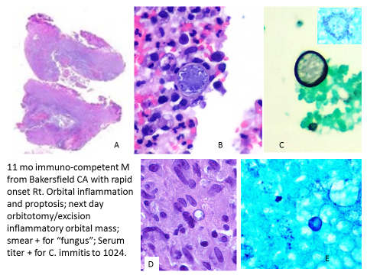

Legend for Fig. 1:
- Scan of H&E stained material with abscess-like topography (oiringal magnnification X 1).
- Spherule within inflammatory debris containing numerous endospores. (H&E original magnification x 200).
- Spherule capsule staining vividly with GMSf (inset: presumed degenerating spherule) GMSf original magnnification X 200)
- Inflammatory debris including a presumed partially sectioned spherule (PAS oiginal magnification X 200).
- Probably dispersed endospores (GMSf original magnfication X 200).

Discussion:

C. immitis is a biphasic fungal organism usually transmitted to humans via respiratory inhalation. The southern San Joaquin valley (indluding Bakersfield) is a well-known site for acquiring this organism.

Limited data is availabler for children in California via California Department of Public Health Data:

Children’s Hospital of Central California Madera, CA:
• Between 2001 and 2009 we averaged 23 admissions per year for coccidioidomycosis
• Beginning in 2009 we experienced an increase in cocci admissions, which became dramatic in 2011 (52 admits) and 2012 (45 admits to date)
• We observed a cluster of mycotic cocci cases from patients living in Avenal, CA, in late 2011 & early 2012
• The number of inpatients on a given day with mycotic cocci increased from 1-2 patients, to an average of 8-10 patients, and a max of 16 patients recently
• The outpatient Infectious Disease Clinic practice at Children’s Hospital is now roughly 80-90% mycotic cocci patients

Overall data also from Department of Communicable Disease Calfiornai (DCDC) CM = mycotic cocci

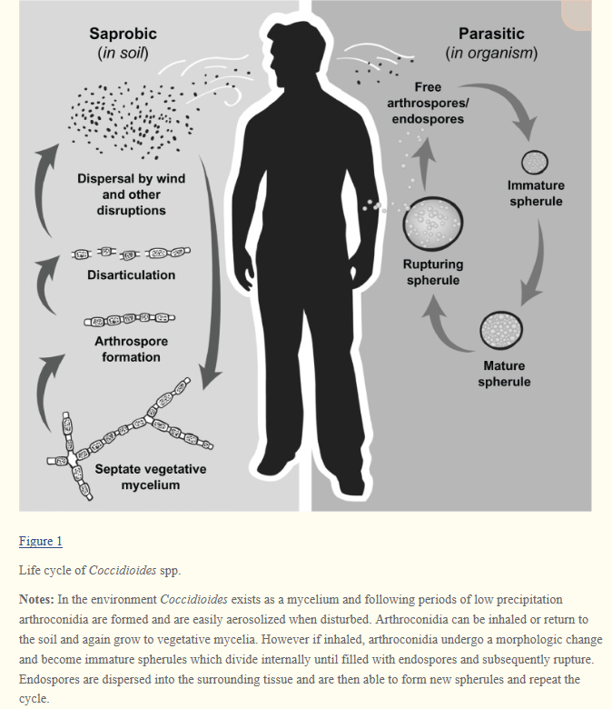
Reference 1

Coccidioidomycosis is caused by Coccidioides immitis, a soil fungus native to the San Joaquin Valley of California (see the image below), and by C posadasii, which is endemic to certain arid-to-semiarid areas of the southwestern United States, northern portions of Mexico, and scattered areas in Central America and South America. Although genetically distinct, the 2 species are morphologically identical. C. immitis can become a chonic granulomatous disease involving multiple organs.

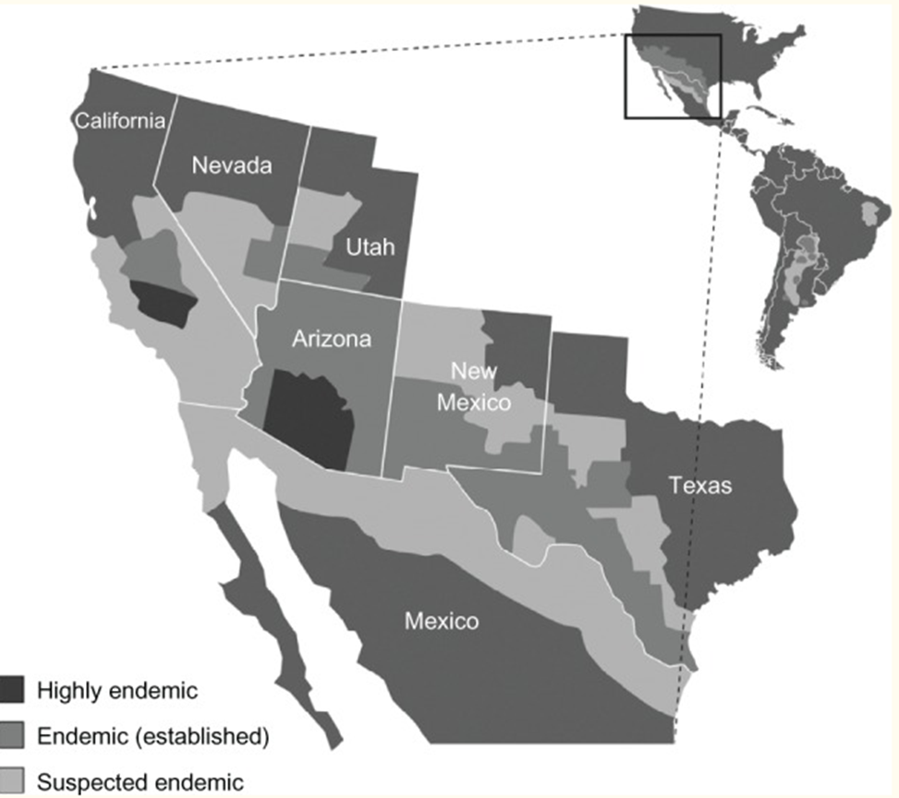
Reference 1 1.

Coccidioidomycosis²
Infection caused by Coccidioides spp. can present with pulmonary, CNS, and osteoarticular involvement. Unlike the lesions of histoplasmosis, the cavities of pulmonary coccidioidomycosis tend to be thin walled, and the nodules do not usually calcify. CNS coccidioidomycosis can cause basilar meningitis with hypopituitarism and basilar granulomatous vasculitis leading to stroke. The bony lesions are osteolytic.

Rammaert et al [89] compared the patterns of osteomyelitis caused by the major endemic dimorphic mycoses. When only 1 osteoarticular site was involved, Sporothrix schenckii most commonly infected joints. By comparison, the most common cause of single bone infection was B dermatitidis. When B dermatitidis, Coccidioides immitis, and H capsulatum infected vertebrae, they most commonly did so as a single site. By comparison, when S. schenckii and Talaromyces (Penicillium) marneffei caused vertebral
osteomyelitis.

References:

- Brown J, Benedict K, Park BJ, Thompson GR, Cocciiodomycosis: epidemiology. Clin Epidemiol. 2013; 5: 185-197. Doi: 10.2147/CLEPS34434
- Aspasia Katragkou Brian T Fisher Andreas H Groll Emmanuel Roilides Thomas J Walsh. Diagnostic Imaging and Invasive Fungal Diseases in Children. Coccidioidomycosis. Journal of the Pediatric Infectious Diseases Society, Volume 6, Issue suppl_1, 1 September 2017, Pages S22–S31, https://doi.org/10.1093/jpids/pix055
Published: 31 August 2017
- Control of Comminoicable Diseases Manuaal. Heymann DL (Ed) 18th Edition, 2004, pages 121-2.

