Eastern Ophthalmic Pathology Society
Annual Meeting 2018
September 13 - 15, Washington, DC

Tatyana Milman, MD
Wills Eye Hospital
840 Walnut street, Suite 1410
Philadelphia, PA 19107, USA
Phone: 215-928-3280, Fax: 215-825-4703
tmilman@willseye.org
tatyana.milman@gmail.com

Secretory carcinoma of the lacrimal gland

Clinical history:
A 52-year-old man presented with diplopia of two weeks duration, associated with progressive proptosis and inferonasal displacement of the right eye over the course of five weeks. Magnetic resonance imaging demonstrated a well-circumscribed, lobulated mass in the right superolateral orbit, suggestive of a low-flow venous malformation or cavernous hemangioma. The mass was resected en block with frozen section control of margins via a lateral orbitotomy approach.

Pathologic findings:
Morphology
Microscopic evaluation demonstrated an encapsulated neoplasm, with foci of dystrophic calcification within its fibrous capsule, adjacent to the lacrimal gland whose lobules were variably atrophic and contained foci of chronic inflammation. The mass had a central cavitary/cystic region filled with subacute hemorrhage, associated with a prominent hemosiderin deposition. In its periphery, the tumor was composed of cells with round-to-ovoid, mildly pleomorphic nuclei and abundant pale eosinophilic, focally vacuolated cytoplasm. No mucocytes (goblet cells) or intracytoplasmic zymogen granules were identified. The neoplastic cells were arranged in papillary and cystic patterns with luminal eosinophilic-to-amphophilic solid and bubbly periodic acid-Schiff (PAS)-positive and Alcian blue-positive dense, colloid-like material. Multifocal areas of penetration of the fibrous capsule by the neoplastic cells were seen. No appreciable extension into the adjacent lacrimal gland parenchyma was noted, however. Mitotic figures were not conspicuous. No necrosis, perineural or lymphovascular invasion were identified. Although the tumor initially was thought to be an oncocytoma, re-evaluation of the morphology and special studies led to the correct diagnosis.
Immunohistochemistry
A panel of immunohistochemical stains was performed to distinguish between secretory carcinoma, oncocytoma / oncocytic carcinoma, the oncocytic variant of mucoepidermoid carcinoma, acinic cell carcinoma, and ductal carcinoma. The neoplastic cells demonstrated positive nuclear and cytoplasmic immunoreactivity for S-100 protein and mammoglobin, supporting the diagnosis of secretory carcinoma. The neoplastic cells lacked expression of p63 (militating against oncocytoma / oncocytic carcinoma and mucoepidermoid carcinoma), DOG-1 (militating against acinic cell carcinoma), and androgen receptors (AR) (militating against salivary duct carcinoma). The Ki-67 proliferation index was approximately 3-5% in the neoplastic cells, consistent with a low-grade lesion.
Fluorescence in situ hybridization
A fluorescence in situ hybridization (FISH) study demonstrated rearrangement within the ETV6 gene in >30% of the tumor cells, confirming the diagnosis of secretory carcinoma.

Discussion:
MASC is a salivary gland malignancy that recapitulates morphologic, immunohistochemical, and molecular features of secretory carcinoma of the breast.¹ Following its original description by Skalova et al, over 200 cases of MASC have been identified in the major and minor salivary glands, leading to its recognition as a new entity in the current 4th Edition of the World Health Organization classification of the salivary gland tumors.^{1,2} Characterization of microscopic, immunohistochemical, and molecular genetic features of MASC has led to its identification in other gland-containing tissues, including the thyroid, esophagus, lung, skin and, most recently, accessory lacrimal glands.^{2,3} In an effort to standardize nomenclature of this neoplasm across organ sites, the official designation for this entity is now simply “secretory carcinoma.”¹
Secretory carcinoma is generally a solitary, well-circumscribed and frequently encapsulated mass, with a cystic, tubular, solid and/or papillary architecture, composed of cells with low-grade nuclei and abundant eosinophilic vacuolated cytoplasm, with intraluminal and/or intracellular colloid-like secretions that stain positively with the Alcian blue and PAS stains and are diastase-resistant. Aggressive features are uncommon, though extracapsular and extraglandular extension, perineural invasion, and high-grade histology have been reported in some cases. Immunohistochemically, this neoplasm usually expresses S-100, mammaglobin, and BRST-2 and is typically negative for p63, DOG-1, AR, and Her2/neu.² Secretory carcinoma usually harbors a characteristic translocation, t(12;15)(p13;q25), resulting in an ETV6-NTRK3 gene fusion, which can be demonstrated by either FISH or PCR. A subset of tumors that are more infiltrative and sclerosing show ETV6 rearrangements with a yet unknown fusion partner.²
Most reported MASCs have been identified from a reappraisal of a heterogeneous group of salivary gland carcinomas with overlapping histology, particularly acinic cell carcinoma and adenocarcinoma not otherwise specified (NOS), allowing for reassessment of this neoplasm’s clinical characteristics and biologic behavior. Based on the data from the salivary gland literature, secretory carcinoma usually occurs in the fourth and fifth decades with a mild male predominance and is occasionally seen in children and the elderly.² Although indolent behavior is the norm, this neoplasm has capacity for locoregional recurrence and may show a slightly higher lymph node metastatic rate (up to 25%) when compared to acinic cell carcinoma. Prognostic features include stage and high-grade transformation.¹ Complete surgical resection of low-grade secretory carcinoma of the salivary glands is usually curative and is the current treatment of choice, in line with the standard of care for low-grade salivary carcinomas. Locoregional radiation therapy can be considered for larger tumors and in the setting of positive margins or perineural invasion. The optimal therapy of salivary gland secretory carcinoma with distant metastasis is not well-defined.²
Our patient presented with a rapid onset of diplopia and proptosis. However, the thick encapsulation with focal calcification of the mass and the overall low-grade morphology of the tumor suggest that intralesional hemorrhage may have contributed to the abruptness of symptoms. Although the sampled intraoperative frozen section margins were negative for malignancy and there was no evidence of wide invasion outside the tumor capsule, we cannot exclude the possibility of microscopic residual disease. Because the behavior of this neoplasm is not characterized in the orbit, the optimal management of our patient is uncertain.
Although secretory carcinoma has not been described to date in the main lacrimal gland, it is likely that a subset of previously identified acinic cell carcinomas, cystadenocarcinomas, ductal adenocarcinomas, oncocytomas / oncocytic cell carcinomas, mucoepidermoid carcinomas, and adenocarcinomas NOS were, in fact, secretory carcinoma.^{4,5} Reappraisal of these neoplasms may help crystallize the clinical characteristics and biologic behavior of lacrimal gland secretory carcinoma, which may, in turn, clarify its management.
Accurate diagnosis of secretory carcinoma with identification of ETV6 rearrangement is therapeutically relevant. The ETV6-NTRK3 gene fusion results in a constitutively active chimeric tyrosine kinase, which leads to downstream activation of cell-proliferative signaling pathways.² This discovery may open the door for targeted therapies, including tyrosine kinase inhibitors and neurotropic tropomyosin receptor kinase (NTRK) inhibitors, which may prove useful in high-grade secretory carcinoma and in metastatic secretory carcinoma.^{2,6}
This study underscores the increasing importance of molecular genetics in the classification of the salivary and lacrimal gland tumors with overlapping morphology. The accurate diagnosis of these neoplasms is essential in order to understand their behavior and to optimize management.

References:
- Seethala RR, Stenman G. Update from the 4th Edition of the World Health Organization Classification of Head and Neck Tumours: Tumors of the Salivary Gland. Head Neck Pathol 2017;11:55-67.
- Skálová A, Gnepp DR, Lewis JS Jr, et al. Newly Described Entities in Salivary Gland Pathology. Am J Surg Pathol 2017;41:e33-e47.
- Bao Y, Li J, Zhu Y. Mammary Analog Secretory Carcinoma With ETV6 Rearrangement Arising in the Conjunctiva and Eyelid. Am J Dermatopathol 2017 Nov 28. doi: 10.1097/DAD.0000000000001062. [Epub ahead of print]
- Bannister M, Lawson G. Papillary-cystic variant of acinic cell carcinoma in the lacrimal gland. Case Rep Ophthalmol Med 2014;2014:285485. doi: 10.1155/2014/285485. Available at: http://dx.doi.org/10.1155/2014/285485. Accessed April 22, 2018.
- Devoto MH, Croxatto JO. Primary cystadenocarcinoma of the lacrimal gland. Ophthalmology 2003;110:2006-10.
- Lange AM, Lo HW. Inhibiting TRK Proteins in Clinical Cancer Therapy. Cancers (Basel) 2018;10. pii: E105. doi: 10.3390/cancers10040105. Available at: http://www.mdpi.com/2072-6694/10/4/105. Accessed April 22, 2018.

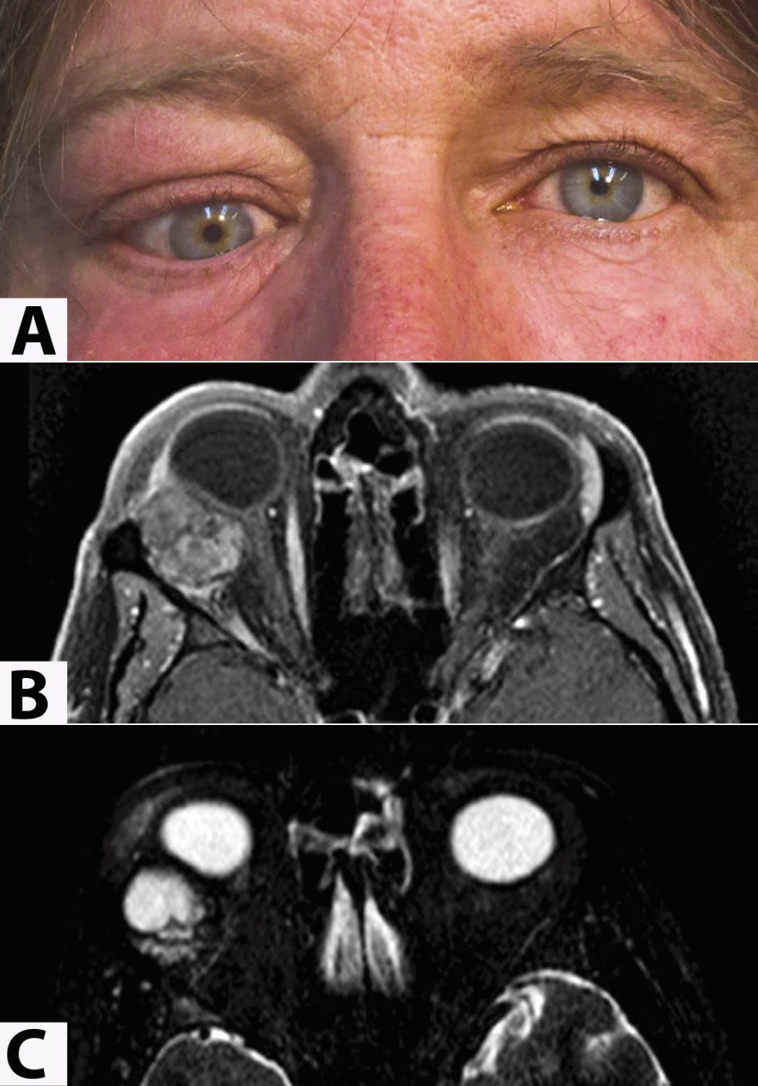
Figure 1. Clinical and radiographic features of lacrimal gland secretory carcinoma
A. External photograph demonstrates proptosis, hypoglobus, hypotropia, and medial displacement of the right eye, associated with upper eyelid fullness.

B. T1-weighted fat-suppressed post-contrast axial magnetic resonance imaging (MRI) demonstrates a well-circumscribed lobulated enhancing mass in the lateral orbit, which indents and displaces the globe.

C. The mass is hyperintense on T2-weighted imaging.

Figure 2. Histopathologic features of lacrimal gland secretory carcinoma

A. At scanning magnification, a well-circumscribed tumor (T), surrounded by a thick fibrous capsule (C) is present adjacent to the atrophic lacrimal gland (L). In this region, the neoplasm is composed of variably-shaped macrocystic, follicle-like structures with abundant eosinophilic secretory material, surrounded by dense fibrous stroma.

B. Higher magnification photomicrograph of another region in the tumor shows cells with mildly pleomorphic round nuclei, abundant eosinophilic vacuolated and foamy cytoplasm, arranged in a mixed solid and microcystic pattern. The cystic spaces contain a bubbly, eosinophilic-to-amphohilic colloid-like secretory material. Hemorrhage is also noted.

C. Periodic acid-Schiff stain following diastase digestion highlights the luminal secretory material. [Stain, hematoxylin-eosin (A, B), PAS/D (C); original magnification x10 (A), original magnification x100 (B, C).

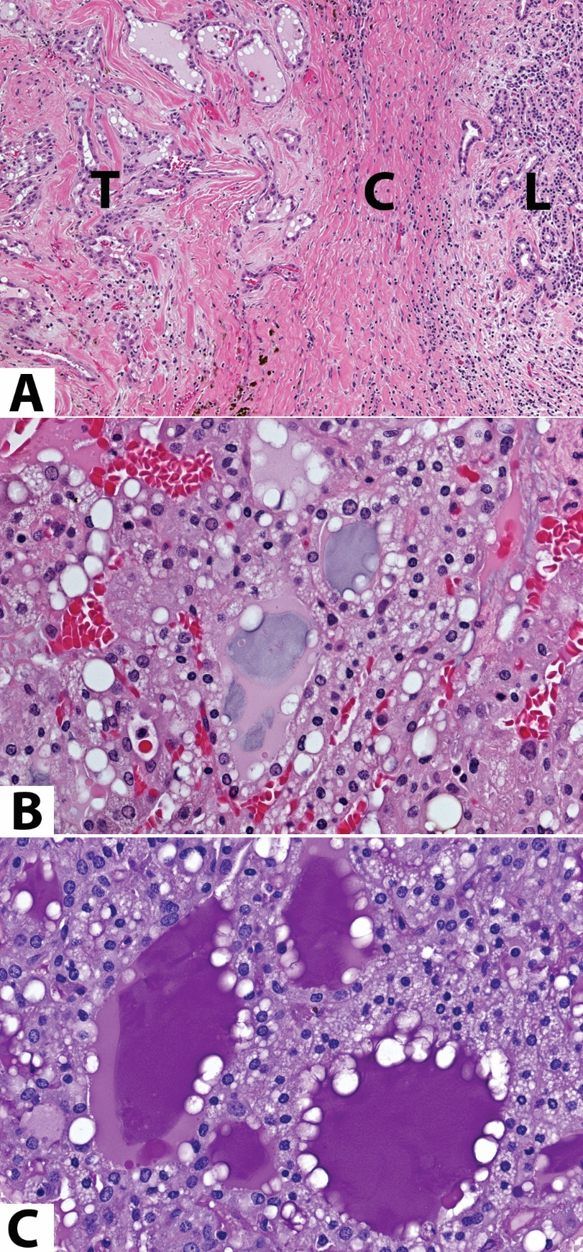

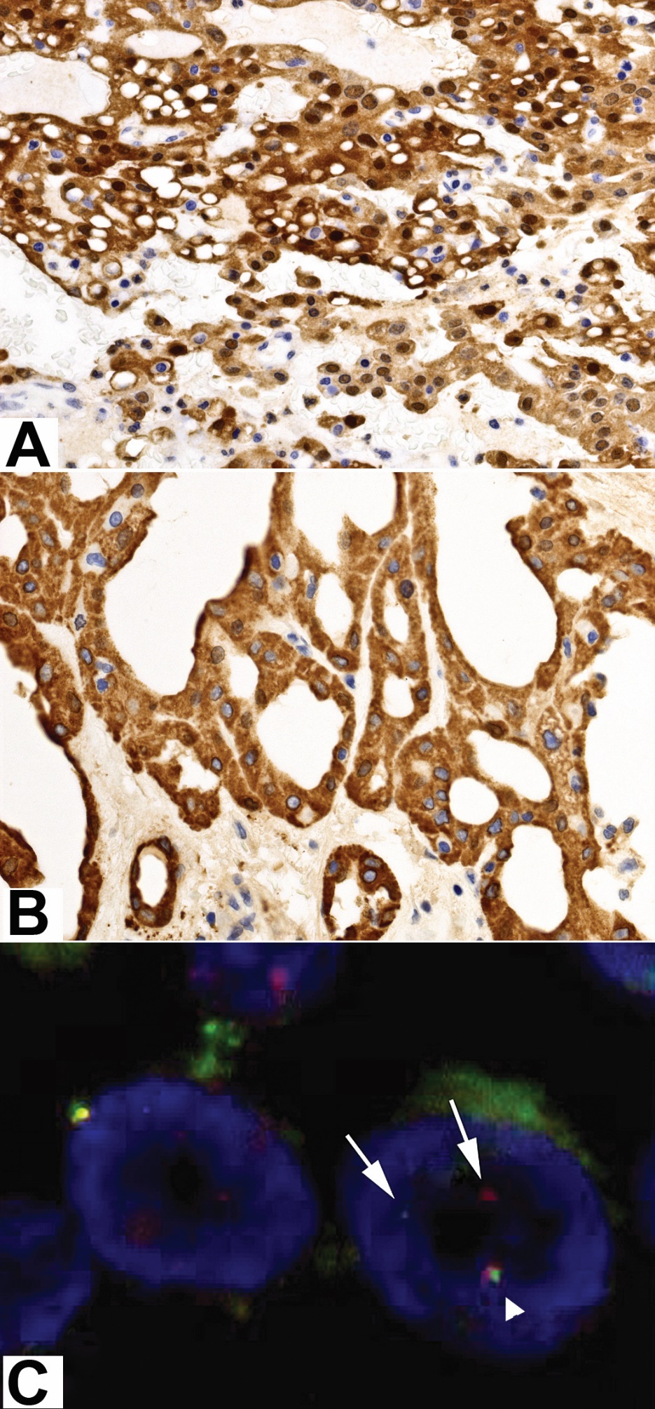
Figure 3. Immunohistochemical and cytogenetic features of lacrimal gland secretory carcinoma.

A. The neoplastic cells demonstrate diffuse nuclear and cytoplasmic expression of S-100 protein.

B. The neoplastic cells diffusely express mammoglobin. [Antibody, S-100 (A) and mammoglobin (B), original magnification x100 (A, B)]

C. ETV6 signal breakapart fluorescence in situ hybridization (FISH) assay shows a pair of breakapart signals (arrows) and a normal allele (fused signals, arrowheads) in two tumor cells.

