2018 Eastern Ophthalmic Pathology Annual Conference
Army-Navy Club, Washington, DC
September 13-15, 2018

Maria Del Valle Estopinal, MD
Assistant Professor of Pathology and Ophthalmology
Director of Eye Pathology
Upstate Medical University
Syracuse, New York
Email address: delvallm@upstate.edu

UNKNOWN CASE
“LOOKING THROUGH WAX PAPER” AFTER CATARACT SURGERY

The patient is a 74 year old male who is referred to the department of Ophthalmology at Upstate Medical University due to “vitreous haze OD” on June 28, 2018. The patient is status post cataract surgery OD, on May 2018 after a right forehead trauma in late April. The cataract surgery was uneventful. At one month follow-up, the patient complains of blurry vision in the right eye.
The past medical history is relevant for “fatigue”, hyperlipidemia, thyroid disease, kidney surgeries, tonsillectomy and cataract in both eyes.
At the ophthalmologic examination, the visual acuity: OD(sc) 20/800 and OS(cc) 20/30+. A mild active inflammation in the anterior chamber of the right eye is identified associated with “a deeper vitritis” composed of larger opacities with a central area that “almost looks like a cyst”. Left eye demonstrates a posterior subcapsular cataract and posterior vitreous detachment.

Color photos, right eye

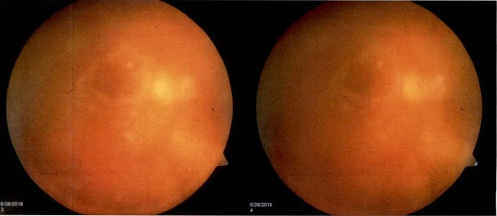

B-Scan, right eye
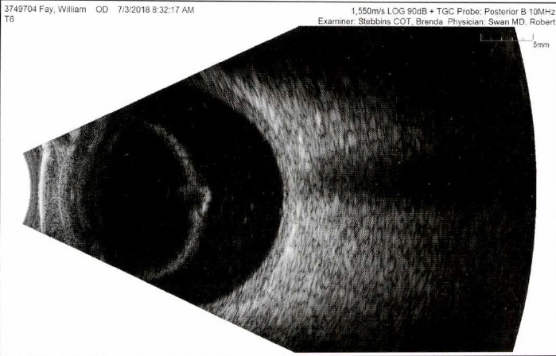

Pars Plana Vitrectomy is recommended (July 3, 2018). Please check the following link to scanned cytopathology slide.
http://cpomnyxweb.upstate.edu/Webviewer/?id=db8a5df59a5b11e880cd40a8f036c343
The protocol and power point presentation will be distributed at the meeting. I will not be able to distribute a glass slide due to the limited amount of tissue.
Looking forward to our discussions.
Maria

