2018 Eastern Ophthalmic Pathology Society
September 2018, Washington DC

Fungus Attacks!

Material Distributed: Protocol and 1 H&E stained slide

Charles G. Eberhart M.D., Ph.D. W. Richard Green Eye Pathology Laboratory
ceberha@jhmi.edu Johns Hopkins University

Clinical History
The patient was a 43 year-old female with a past medical history significant for monocytic acute myeloid leukemia (AML) with FLT3 ITD mutation. She was first diagnosed with AML in July 2017, and subsequently had refractory disease despite multiple treatment protocols. An ophthalmic exam performed in February 2018 was normal aside from some vitreous floaters.
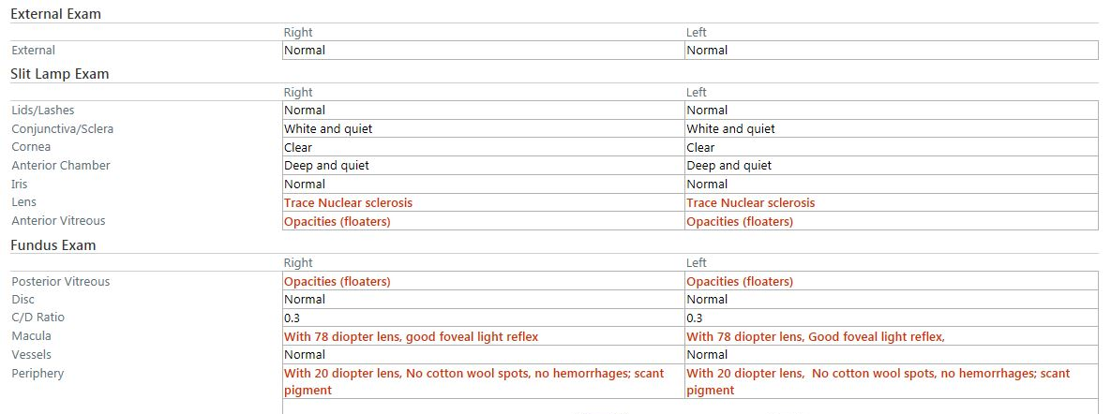
In early May 2018, she was found to have a right frontal lobe brain mass and CNS involvement of her leukemia. She was treated with multiple courses of intrathecal chemotherapy, antibiotics, and antifungal therapy. In May, she was readmitted to Johns Hopkins Hospital for altered mental status, headache, and fevers. Her brain mass progressed, despite treatment, and was concerning for an invasive fungal infection. She was transitioned to comfort care and died in late May 2018. Blood cultures subsequently grew out Lomentospora prolificans (formerly known as Scedosporium prolificans).
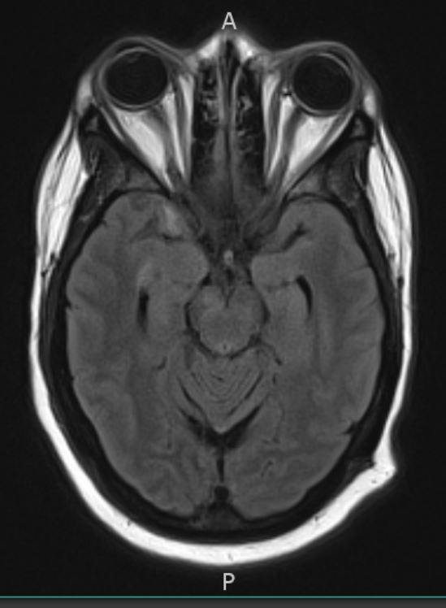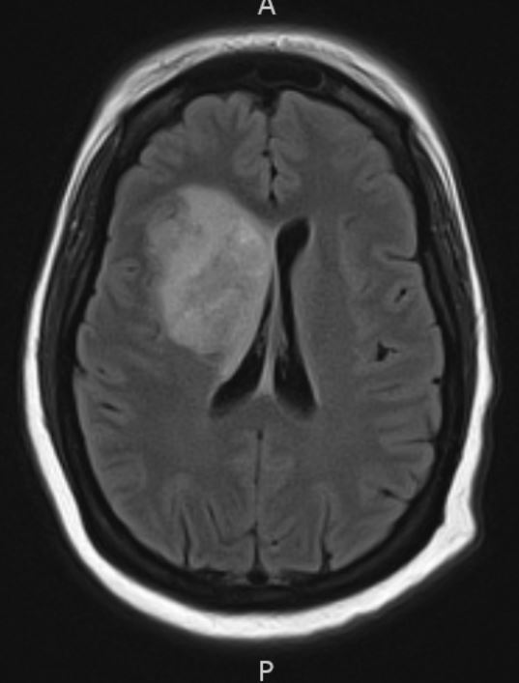

Pathological Findings
A complete autopsy was consented for and performed with a postmortem interval of 44 hours. The autopsy demonstrated systemic invasive fungal infection, involving the brain, heart, stomach, thyroid, and kidney. Histologically, the fungal hyphae were septate, with acute angle branching, and on a morphological basis were consistent with the ante mortem culture of Lomentospora. Additionally, there were multiple hemorrhages and infarctions in the cerebral hemispheres, cerebellum, and brainstem secondary to invasive fungal infection. The patient's acute myeloid leukemia was identified in the brain, eye, breast, kidney, and possibly spleen, with persistent disease present in the bone marrow. The cause of death was listed as systemic invasive fungal infection due to immunosuppression as a consequence of treatment for acute myeloid leukemia.
Ocular findings at autopsy included an atypical mononuclear cell infiltrate most prominent in the choroid, consistent with involvement by AML. In addition, fungal forms were present throughout the globe, including the sclera, choroid, retina and vitreous.

Discussion
Acute myeloid leukemia (AML) accounts for 1% of adult cancer deaths in the United States. The mean age of diagnosis is approximately 65 years. The malignancy arises from a clonal expansion of myeloid lineage, and may be preceded by myelodysplastic syndrome (MDS), myeloproliferative neoplasms (MPN), paroxysmal nocturnal hemoglobinuria, or aplastic anemia. Environmental factors, including chemical exposures, radiation, tobacco, chemotherapy, and retroviruses, have been associated with the disease. Progression has been associated with age. For patients between the ages of 40 to 59, the 5-year survival is only 33%. Various non-random chromosomal translocations, including BCR-ABL1 fusion, and mutations, including FLT3-ITD and TP53, are associated with poor outcomes [1-3].
Infections with the three broad groups of non-Aspergillus filamentous fungi (the mucormycetes, the hyalohyphomycetes and the phaeohyphomycetes) are increasingly reported, particularly in the context of immunosuppression [4]. The most common of these include Rhizopus, Mucor, Fusarium and Scedosporium species. Lomentospora (Scedosporium) prolificans is resistant to most current antifungal agents [5]. Reported ocular cases of S. prolificans endophthalmitis have frequently been associated with immunosuppression, sometimes due to AML, and generally result in enucleation [6-9] or the patient’s death [10-13]. In some cases, however, vision was preserved, including a 9 year-old girl with AML, [14, 15]. A case of Scedosporium apiospermum infectious scleritis has also been reported after a posterior sub-tenons injection [16].

References

1. Dohner, H., et al., Diagnosis and management of AML in adults: 2017 ELN recommendations from an international expert panel. Blood, 2017. 129(4): p. 424-447.
2. Shah, A., et al., Survival and cure of acute myeloid leukaemia in England, 1971-2006: a population-based study. Br J Haematol, 2013. 162(4): p. 509-16.
3. Santamaria, C.M., et al., Molecular stratification model for prognosis in cytogenetically normal acute myeloid leukemia. Blood, 2009. 114(1): p. 148-52.
4. Douglas, A.P., S.C. Chen, and M.A. Slavin, Emerging infections caused by non-Aspergillus filamentous fungi. Clin Microbiol Infect, 2016. 22(8): p. 670-80.
5. Pellon, A., et al., Pathobiology of Lomentospora prolificans: could this species serve as a model of primary antifungal resistance? Int J Antimicrob Agents, 2018. 51(1): p. 10-15.
6. Taylor, A., S.J. Wiffen, and C.J. Kennedy, Post-traumatic Scedosporium inflatum endophthalmitis. Clin Exp Ophthalmol, 2002. 30(1): p. 47-8.
7. Wood, G.M., et al., Clinical features of human infection with Scedosporium inflatum. Clin Infect Dis, 1992. 14(5): p. 1027-33.
8. Marin, J., et al., Disseminated Scedosporium inflatum infection in a patient with acute myeloblastic leukemia. Eur J Clin Microbiol Infect Dis, 1991. 10(9): p. 759-61.
9. Inoda, S., et al., [Bilateral Endogenous Fungal Subretinal Abscesses due to Scedosporium prolificans: a Case Report]. Nippon Ganka Gakkai Zasshi, 2015. 119(9): p. 632-9.
10. Maertens, J., et al., Disseminated infection by Scedosporium prolificans: an emerging fatality among haematology patients. Case report and review. Ann Hematol, 2000. 79(6): p. 340-4.
11. McKelvie, P.A., et al., Scedosporium endophthalmitis: two fatal disseminated cases of Scedosporium infection presenting with endophthalmitis. Clin Exp Ophthalmol, 2001. 29(5): p. 330-4.
12. Vagefi, M.R., et al., Bilateral endogenous Scedosporium prolificans endophthalmitis after lung transplantation. Am J Ophthalmol, 2005. 139(2): p. 370-3.
13. Jain, A., et al., Endogenous Scedosporium apiospermum endophthalmitis. Arch Ophthalmol, 2007. 125(9): p. 1286-9.
14. Chiam, N., et al., Scedosporium prolificans endogenous endophthalmitis. J AAPOS, 2013. 17(6): p. 627-9.
15. Bui, D.K. and P.E. Carvounis, Favorable Outcomes of Filamentous Fungal Endophthalmitis Following Aggressive Management. J Ocul Pharmacol Ther, 2016. 32(9): p. 623-630.
16. Todokoro, D., et al., Scedosporium apiospermum infectious scleritis following posterior subtenon triamcinolone acetonide injection: a case report and literature review. BMC Ophthalmol, 2018. 18(1): p. 40.

