EASTERN OPHTHALMIC PATHOLOGY SOCIETY
Washington DC
September 13-15, 2018

1- Dr. Hind M Alkatan
Assistant Professor, Director of KSU Residency & Fellowship Training Programs in Ophthalmology
Associate Director-External Accreditation Unit, Post-Graduate Medical Education Department.
Consultant, Departments of Ophthalmology & Pathology,
College of Medicine, King Saud University Medical City.
Tel. No: +966 504492399
Email: hindkatan@yahoo.com; hkatan@ksu.edu.sa
2- Prof. Yasser H. Al-Faky
3- Prof Ammar Alrikabi
4- Dr. Saleh Alrashed

Youngest case report of orbital T- cell lymphoma with literature review: Early diagnosis, management and successful outcome.

The Case:
History:
A 3-year-old Syrian male child with gradual progressive painless swelling of the left lower eyelid and ptosis of the upper eyelid over the course of 2 months that significantly increased over the last 2 weeks.
Medically, the parents recalled loss of appetite of one-week duration.
He had unremarkable family history.
Ophthalmological examination:
Left orbital dystopia, supero-rmedial displacement of the left globe, limited EOM in up-gaze of the left eye, and pseudo-ptosis of the left upper lid.
Palpebral fissure measurements: left eye 5 mm/ right eye 9 mm.
Further examination of the left orbit revealed a hard lesion involving the inferior orbital rim and the lateral aspect of the orbital cavity, measuring 2 cm horizontally by 1.5 cm vertically. There was no proptosis, overlying skin changes or palpable lymphadenopathy.
An Incisional biopsy under general anesthesia was performed and a 2.1 x 1.5 x 1.0 cm tissue was obtained. The patient’s clinical appearance improved after the biopsy.

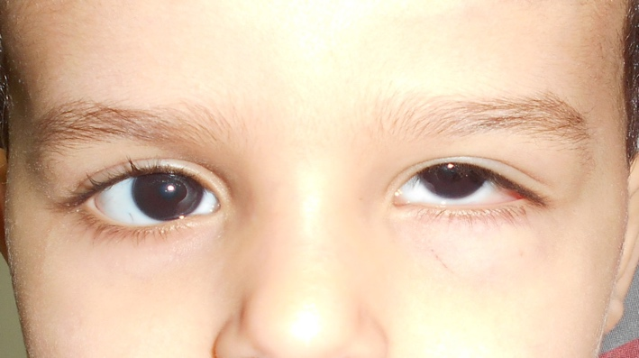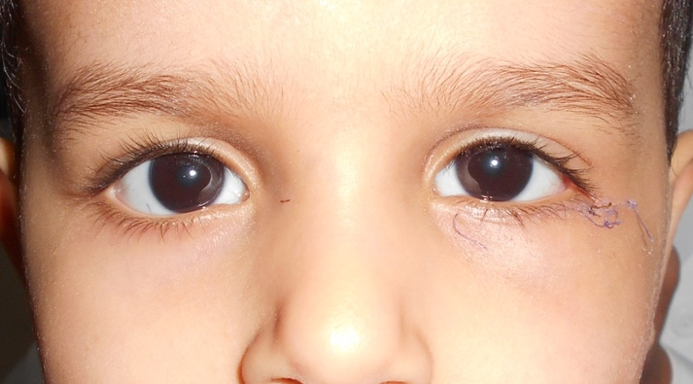
Pre-Op. Post-op.

Magnetic Resonance Imaging (MRI) of the orbits showed a solid enhancing mass lesion, involving the lateral and inferior walls of the left orbit, extending into the intraconal compartment, and displacing the globe superiorly and medially with medial displacement of the left inferior rectus muscle.
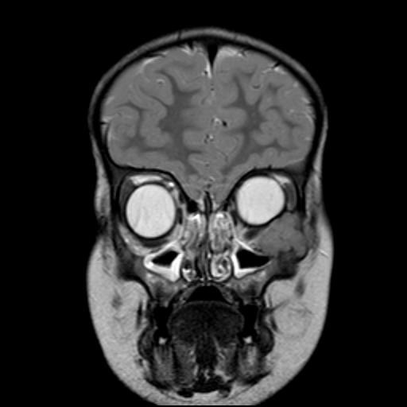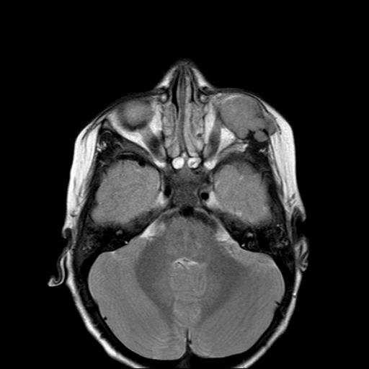

Histopathology:
Diffuse effacement atypical cells of variable size infiltrating the bone (Figure 2A). The proliferating cells often have clear cytoplasm, resembling Reed-Sternberg cells. Many mitotic figures were seen, consistent with non-Hodgkin’s lymphoma (Figure 2B).
IHC stains showed that the tumor cells were expressing T-cell markers including CD3, CD4, CD8, and CD43 (Figures 2C, D, E & F). Stains for B-cell markers CD20, CD21, CD30, CD56 and Granzyme B (as a marker for natural killer cells) were all negative. Stain for Terminal deoxynucleotidyl Transferase (TdT) as a marker for non-Hodgkin’s lymphoblastic lymphoma was also negative.
DNA from the biopsy was extracted and qualitative PCR was done and showed T-cell receptor (TCR Beta and TCR Gamma) gene rearrangement, confirming the diagnosis of PTCL-NOS.

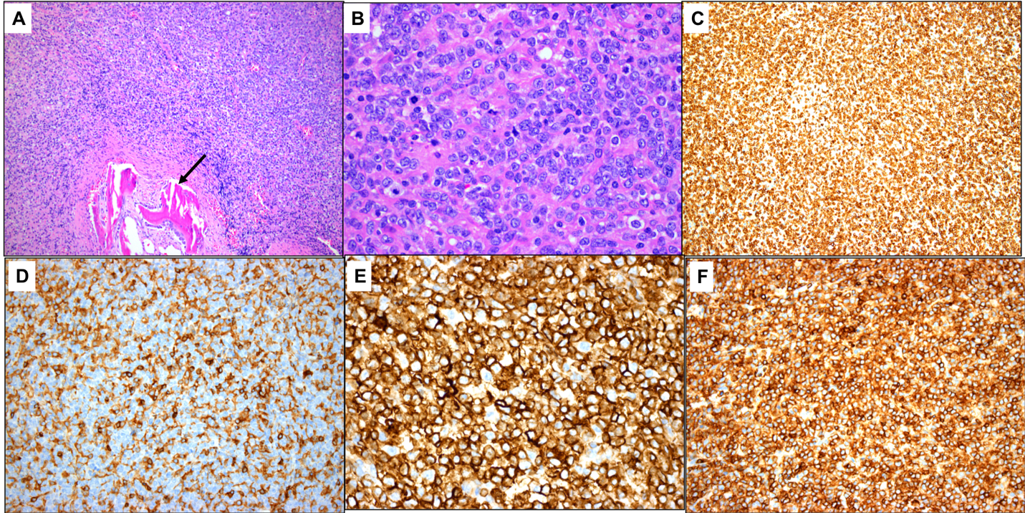

Discussion:
Orbital and ocular adnexal lymphoid neoplasms are not scarce, representing 6% to 8% of all orbital tumors, whereas out of the extra-nodal Non-Hodgkin’s lymphoma primary Non-Hodgkin’s lymphoma of the orbit represented 8–10%. ^{7, 8} On the basis of case series, the most reported orbital lymphoid tumor was B-cell non-Hodgkin malignant lymphoma. ^{7, 9} In 1998, Coupland analyzed 112 cases of ocular adnexal lymphoproliferative disorder, T-cell lymphoma was encountered in only 3 cases. These cases were all systemic. ⁹ Peripheral T-cell lymphomas in general are aggressive neoplasms with a poor outcome. Primary orbital PTCL-NOS of the orbit has been rarely reported with, to the best of our knowledge, only 6 cases being reported in the English-written literature including ours. ^{2–6}
Our case, of a 3-year-old child diagnosed with primary orbital peripheral T-cell lymphoma is unique in the sense that he is the youngest case of primary PTCL-NOS of the orbit ever reported, presentation of our patient with pseudo-ptosis was unique, and the consistency of a hard mass clinically and by imaging gave an impression of a bony origin, such as Ewing sarcoma. The early accurate diagnosis allowed for proper promising treatment with resolution of the mass over a 1-year period.

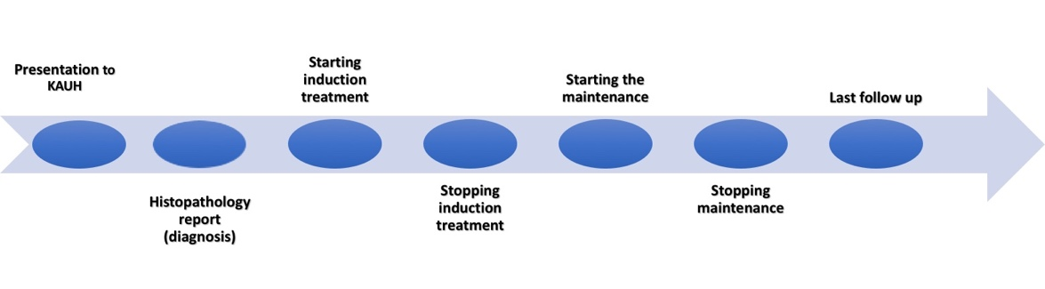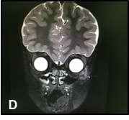
Conclusion:
We strongly recommend the following: 1- A high level of suspicion of such entities regardless of the age or presentation. 2- Careful histopathological examination and proper tissue diagnosis by experienced pathologist, which is very critical in confirming the diagnosis for early intervention.

References:
1. Swerdlow SH, Campo E, Pileri SA, Harris NL, Stein H, Siebert R, Advani R, Ghielmini M, Salles GA, Zelenetz AD, Jaffe ES. The 2016 revision of the World Health Organization classification of lymphoid neoplasms. Blood 127, (2016).
2. Coupland SE, Foss HD, Assaf C, Auw-Haedrich C, Anastassiou G, Anagnostopoulos I, Hummel M, Karesh JW, Lee WR, Stein H. T-cell and T/natural killer-cell lymphomas involving ocular and ocular adnexal tissues: a clinicopathologic, immunohistochemical, and molecular study of seven cases. Ophthalmology 106, 2109–20 (1999).
3. Lee DS, Woo KI, Chang HR. T-cell lymphoma presenting as painful ophthalmoplegia. Korean J. Ophthalmol. 20, 192–4 (2006).
4. Janatpour KA, Choo PH, Lloyd WC. Primary orbital peripheral T-cell lymphoma: histologic, immunophenotypic, and genotypic features. Arch. Ophthalmol. (Chicago, Ill. 1960) 125, 1289–92 (2007).
5. Chen YJ, Chen JT, Lu DW, Gao HW, Tai MC. Primary Peripheral T-Cell Lymphoma of the Orbit. Arch. Ophthalmol. 127, 1070 (2009).
6. Amit S, Purwar N, Agarwal A, Kanchan S. Primary orbital non-Hodgkin’s lymphoma. BMJ Case Rep. bcr2012006847- (2012).
7. Gagnier JJ, Kienle G, Altman DG, Moher D, Sox H, Riley D, the CARE Group. The CARE guidelines: consensus-based clinical case reporting guidline development. BMJ Case Reports doi:10.1136/bcr-2013-201554 (2013).
8. Shields J A, Shields CL, Scartozzi R. Survey of 1264 patients with orbital tumors and simulating lesions: The 2002 Montgomery Lecture, part 1. Ophthalmology 111, 997–1008 (2004).
9. Freeman C, Berg JW, Cutler S.J. Occurrence and prognosis of extranodal lymphomas. Cancer 29, 252–260 (1972).
10. Coupland S E, Krause L, Delecluse HJ, Anagnostopoulos I, Foss HD, Hummel M, Bornfeld N, Lee WR, Stein H. Lymphoproliferative lesions of the ocular adnexa: Analysis of 112 cases. Ophthalmology 105, 1430–1441 (1998).
11. Weisenburger D D, Savage KJ, Harris NL, Gascoyne RD, Jaffe ES, MacLennan KA, Rudiger T, Pileri S, Nakamura S, Nathwani B, Campo E, Berger F, Coiffier B, Kim W-S, Holte H, Federico M, Au WY, Tobinai K, Armitage JO, Vose JM; International Peripheral T-cell Lymphoma Project. Peripheral T-cell lymphoma, not otherwise specified: a report of 340 cases from the International Peripheral T-cell Lymphoma Project. Blood 117(12), 3402–8 (2011). doi: 10.1182/blood-2010-09-310342.
12. Savage KJ, Harris NL, Vose JM, Ulrich F, Jaffe ES, Connor JM, Rimsza L, Pileri SA, Chhanabhai M, Gascoyne RD, Armitage JO, Weisenburger DD; International Peripheral T-cell Lymphoma Project. ALK− anaplastic large-cell lymphoma is clinically and immunophenotypically different from both ALK+ ALCL and peripheral T-cell lymphoma, not otherwise specified: report from the International Peripheral T-Cell Lymphoma Project. Blood 111, (2008). doi: 10.1182/blood-2008-01-134270
13. d’Amore F, Gaulard P, Trumper L, Corradini P, Kim WS, Specht L, Bjerregaard Pedersen M, Ladetto M; ESMO Guidelines Committee. Peripheral T-cell lymphomas: ESMO Clinical Practice Guidelines for diagnosis, treatment and follow-up. Ann. Oncol. 26, Suppl 5: v108–v115 (2015). doi: 10.1093/annonc/mdv201
14. Agostinelli C, Piccaluga PP, Went P, Rossi M, Gazolla A, Righi S, Sista T, Campidelli C, Zinzani PL, Falini B, Pileri SA. Peripheral T-cell lymphoma, not otherwise specified: the stuff of genes, dreams and therapies. J Clin Pathol 2008; 61:1160–1167. doi:10.1136/jcp.2008.055335

