CHILDREN’S HOSPITAL NP CONFERENCE CASE 9.24.2010

T2 flair
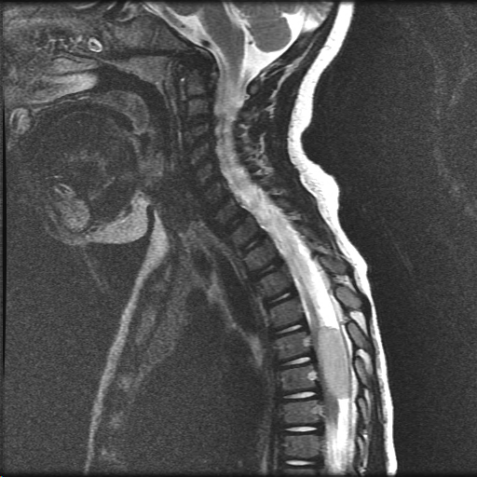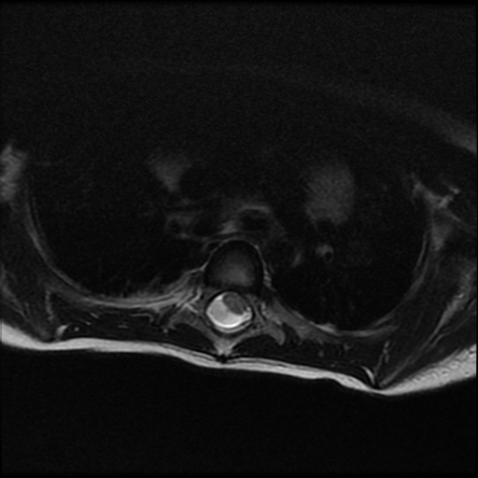
+Contrast
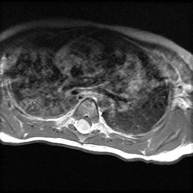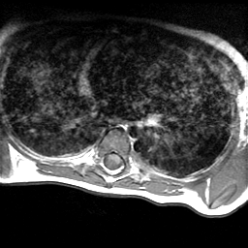

1 y/o female losing early walking skill.

Describe radiologic lesion. What is differential? (in this age group?)

http://image.upmc.edu:8080/NeuroPathology/PediatricTumors/PediatricTumor2/PT.16.svs/view.apml?

What special stains would you order and how would you interpret the results?

