CHILDREN’S HOSPITAL CONFERENCE CASE 9.18.2015

15y/o F had grand mall seizure after 3 months of progressive headaches.
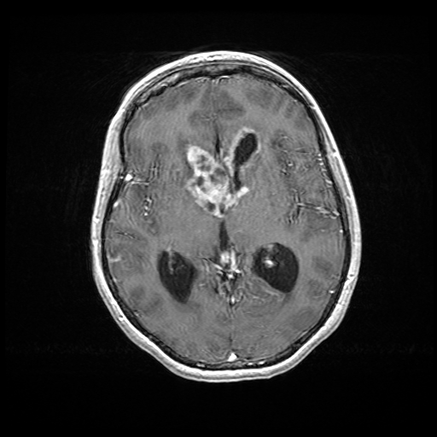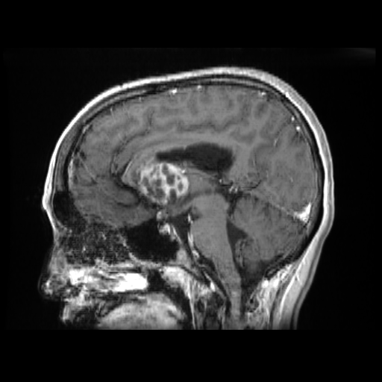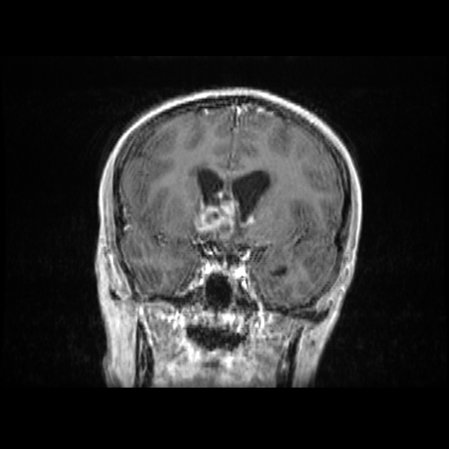
T1 with contrast

Surgical specimen: Endoscopic trans-lamina terminalis fenestration, shunt and biopsy:

H&E: http://image.upmc.edu:8080/NeuroPathology/NonGlialTumors/NonGlialTumors7/NG.248a.svs/view.apml?
cKit http://image.upmc.edu:8080/NeuroPathology/NonGlialTumors/NonGlialTumors7/NG.248e.svs/view.apml?
Oct4 http://image.upmc.edu:8080/NeuroPathology/NonGlialTumors/NonGlialTumors7/NG.248d.svs/view.apml?
AE1/3 http://image.upmc.edu:8080/NeuroPathology/NonGlialTumors/NonGlialTumors7/NG.248c.svs/view.apml?

Diagnosis: Germ cell tumor

