CHILDREN’S HOSPITAL CONFERENCE CASE 9.18.2015

15y/o F had grand mall seizure after 3 months of progressive headaches.
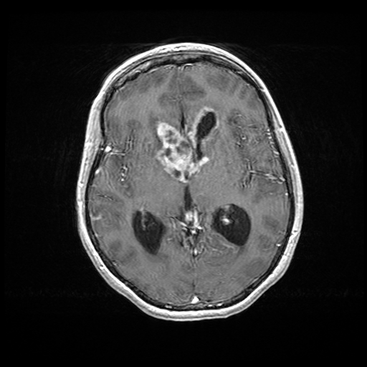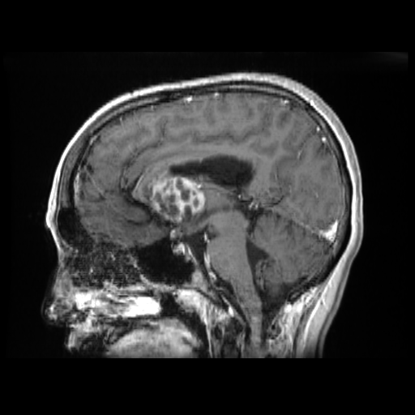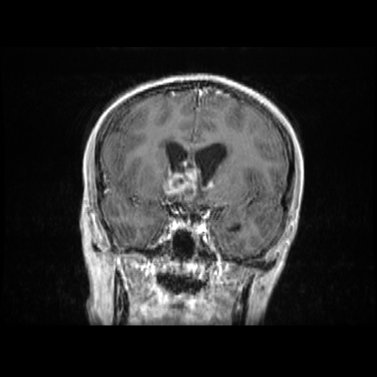
T1 with contrast

Surgical specimen: Endoscopic trans-lamina terminalis fenestration, shunt and biopsy:

SMEAR http://image.upmc.edu:8080/NeuroPathology/NonGlialTumors/NonGlialTumors7/NG.248b.svs/view.apml?
Suboptimal but what information can you extract from it, how does it fit with your DDx?

H&E: http://image.upmc.edu:8080/NeuroPathology/NonGlialTumors/NonGlialTumors7/NG.248a.svs/view.apml?
Give differential, Suggested workup and favored likely diagnosis.

