Neuropathology case
Children’s Hospital Friday September 17th, 2010 8AM conference
Male infant who was delivered prematurely at 30.5 weeks gestation due to intrauterine growth restriction. Discovered to have significant cardiac abnormalities and despite aggressive therapy died of multi-organ failure after 2 weeks
Autopsy Gross Photo
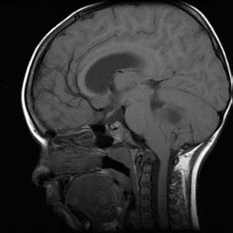
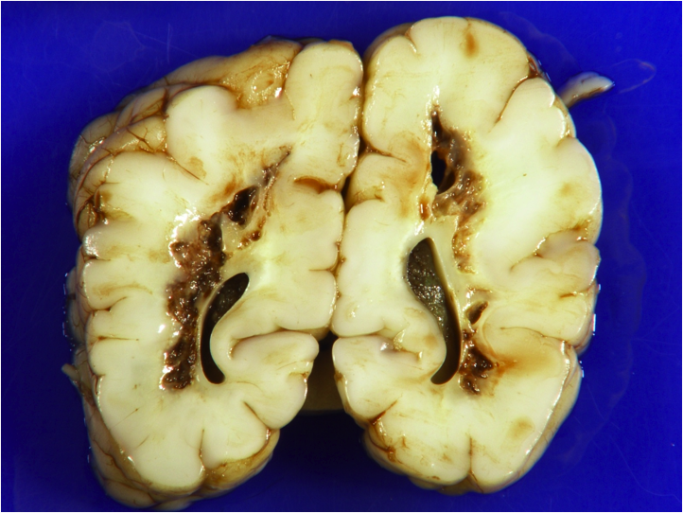
Describe gross findings
Describe H&E findings
H&E
Diagnosis- Periventricular Leukomalacia (PVL)

