CHILDREN’S HOSPITAL NP CONFERENCE CASE
September 13, 2013 Clayton Wiley
5 year old with 2.5 month history of headaches and right exophthalmos
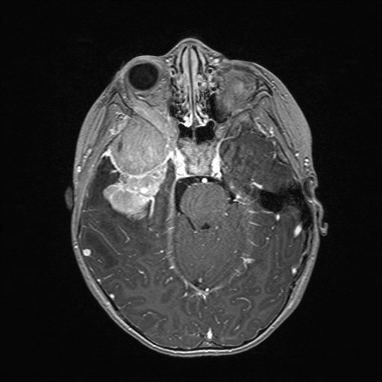
Recent onset of right-sided pupil dilation
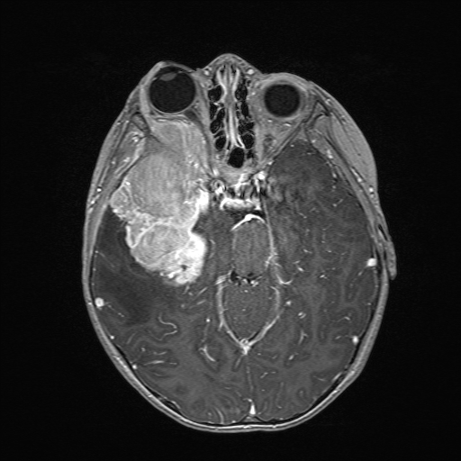
H&E Smear
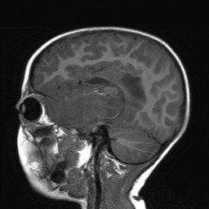
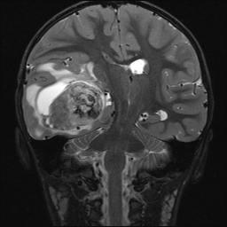
Intraop Dx? Stains to order up front?

Answer:
Ewings Sarcoma
Permanent H&E
Permanent CD99
Permanent Synaptophysin

