Neuropathology Case

Children’s Hospital Conference, Friday August 14, 2015

25 yo male with right-sided hemiparesis and seizure disorder. He was found dead in his bed.

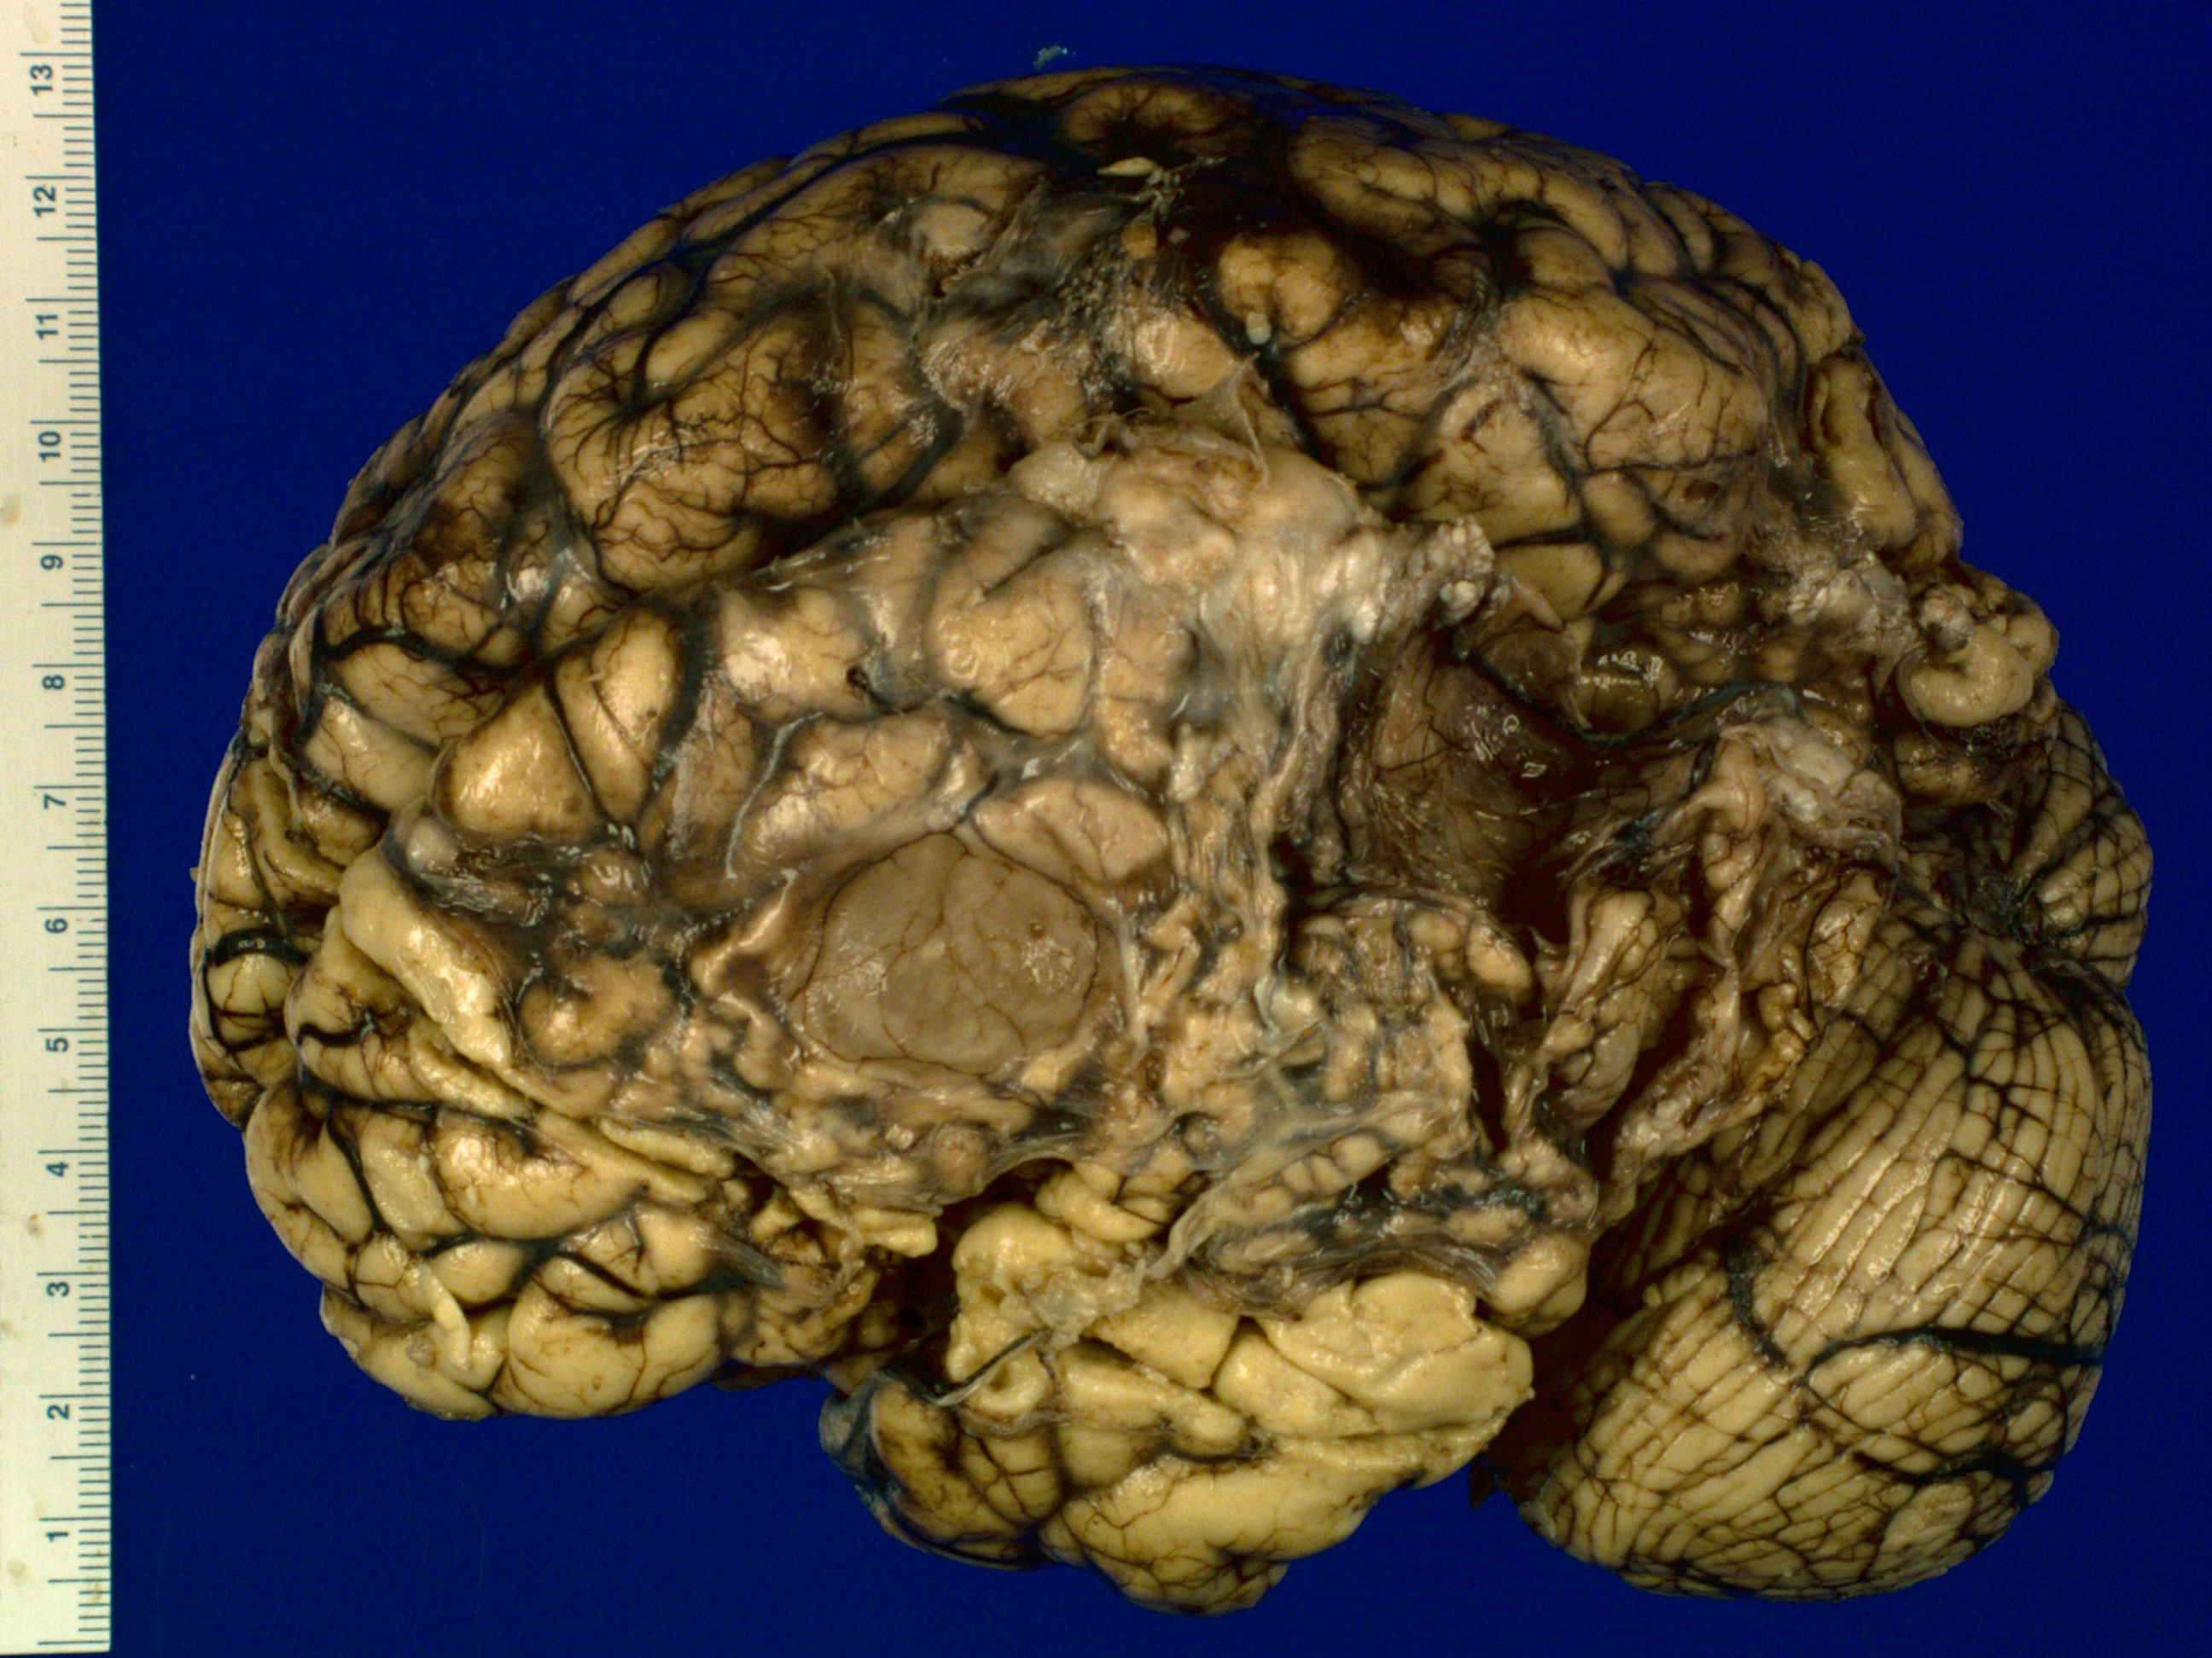
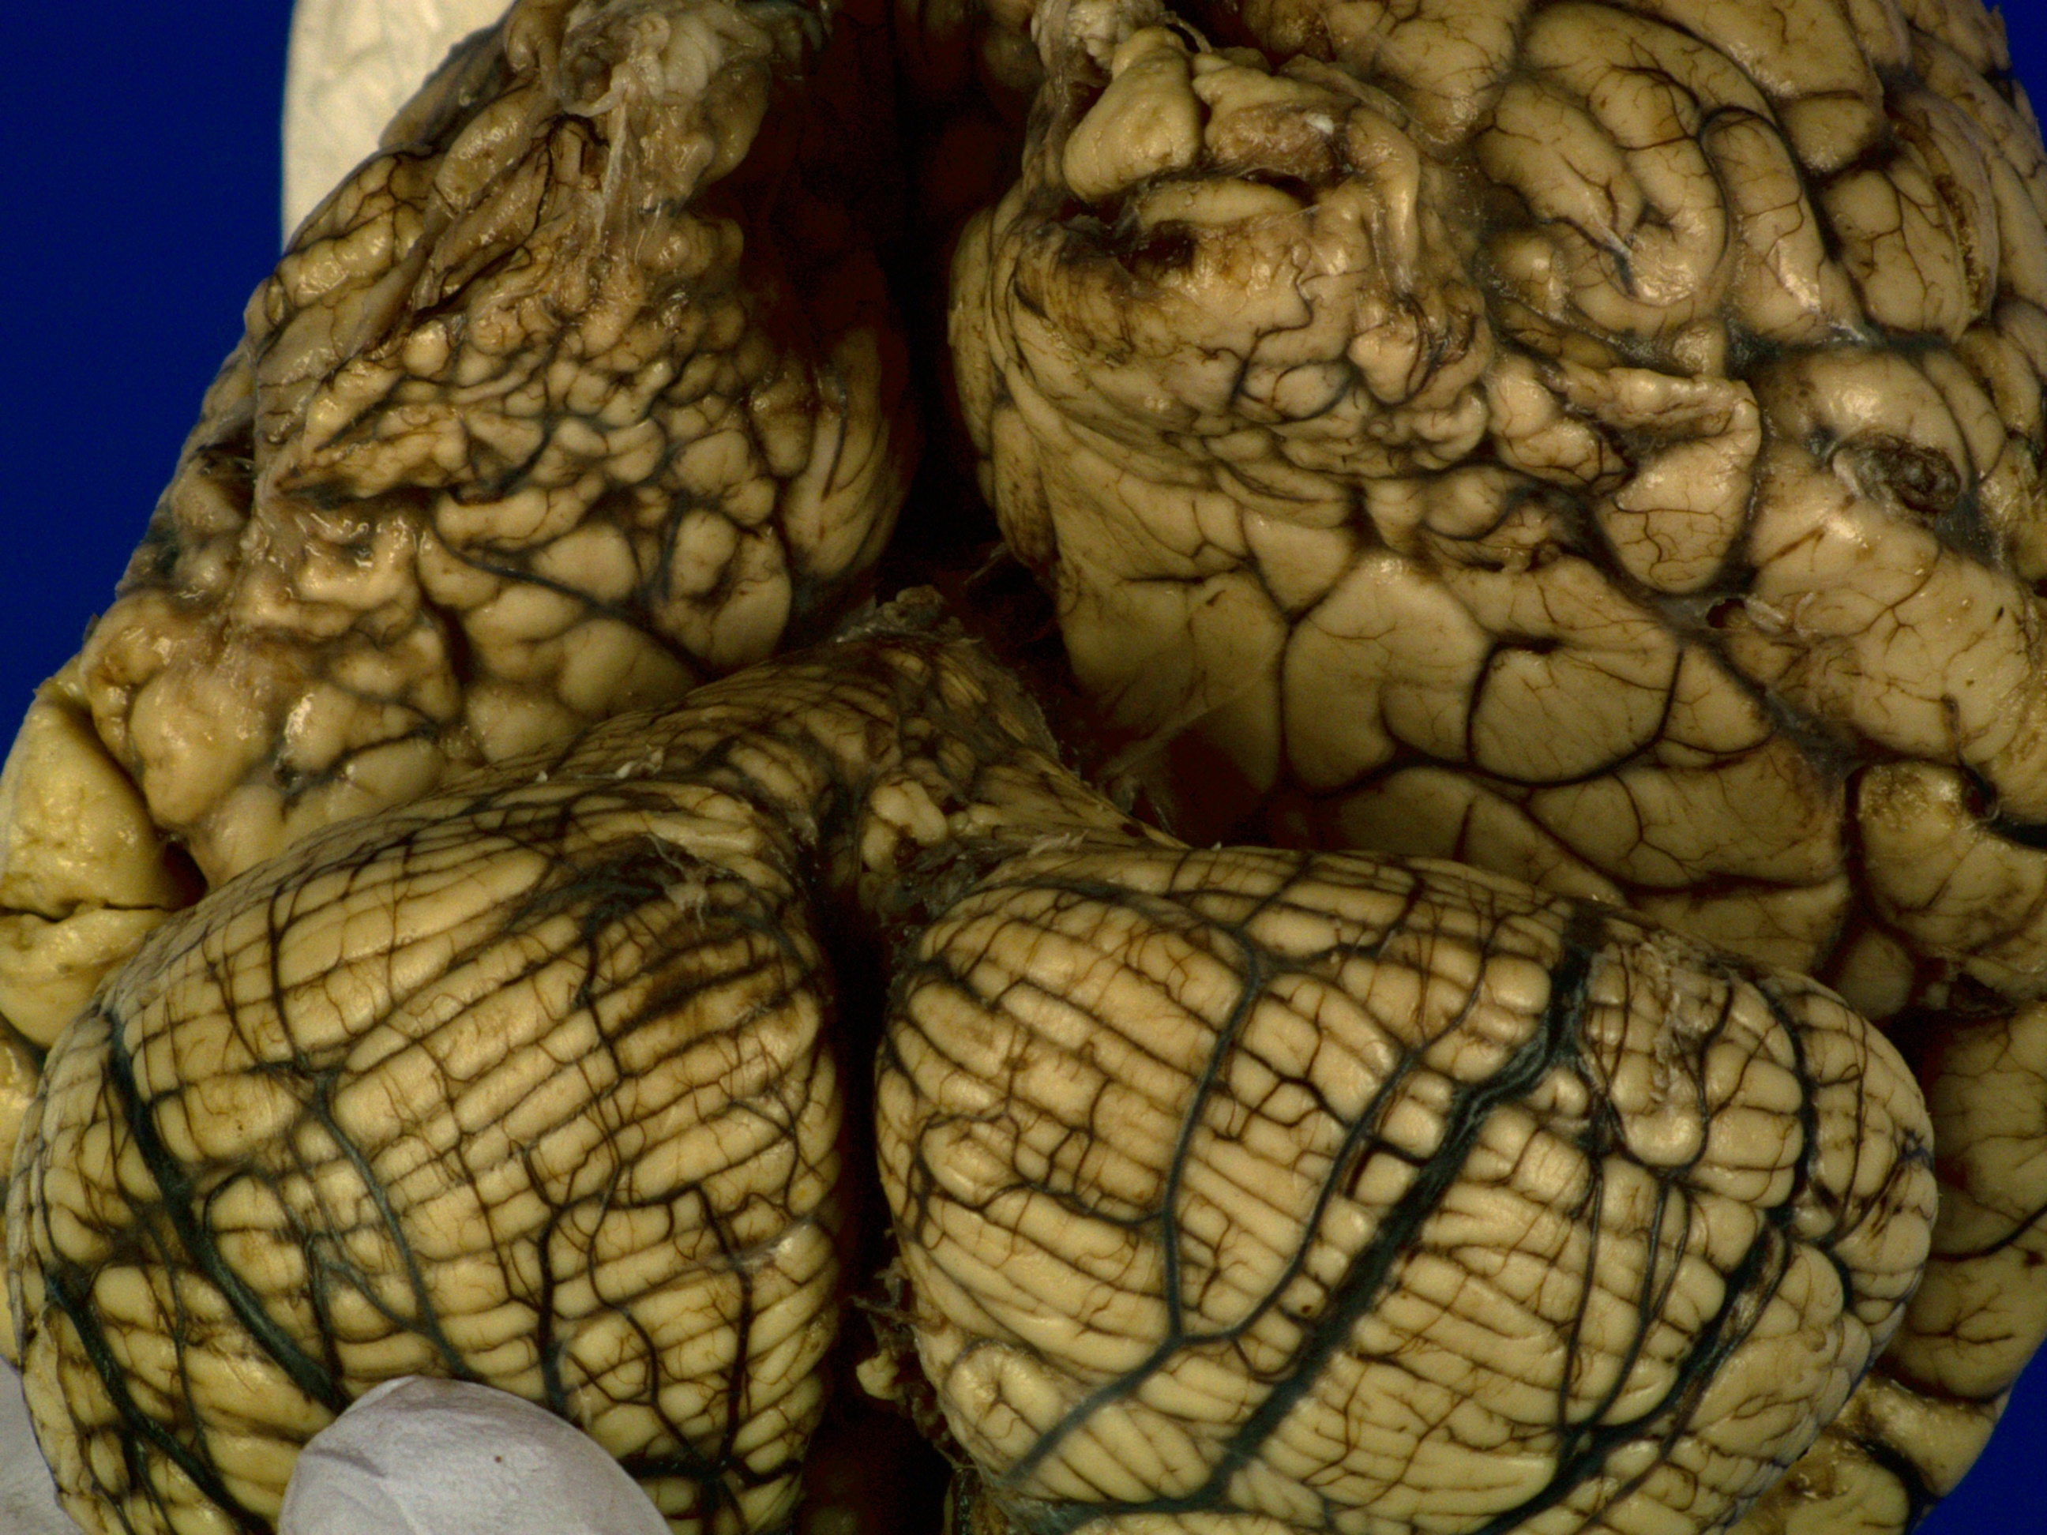
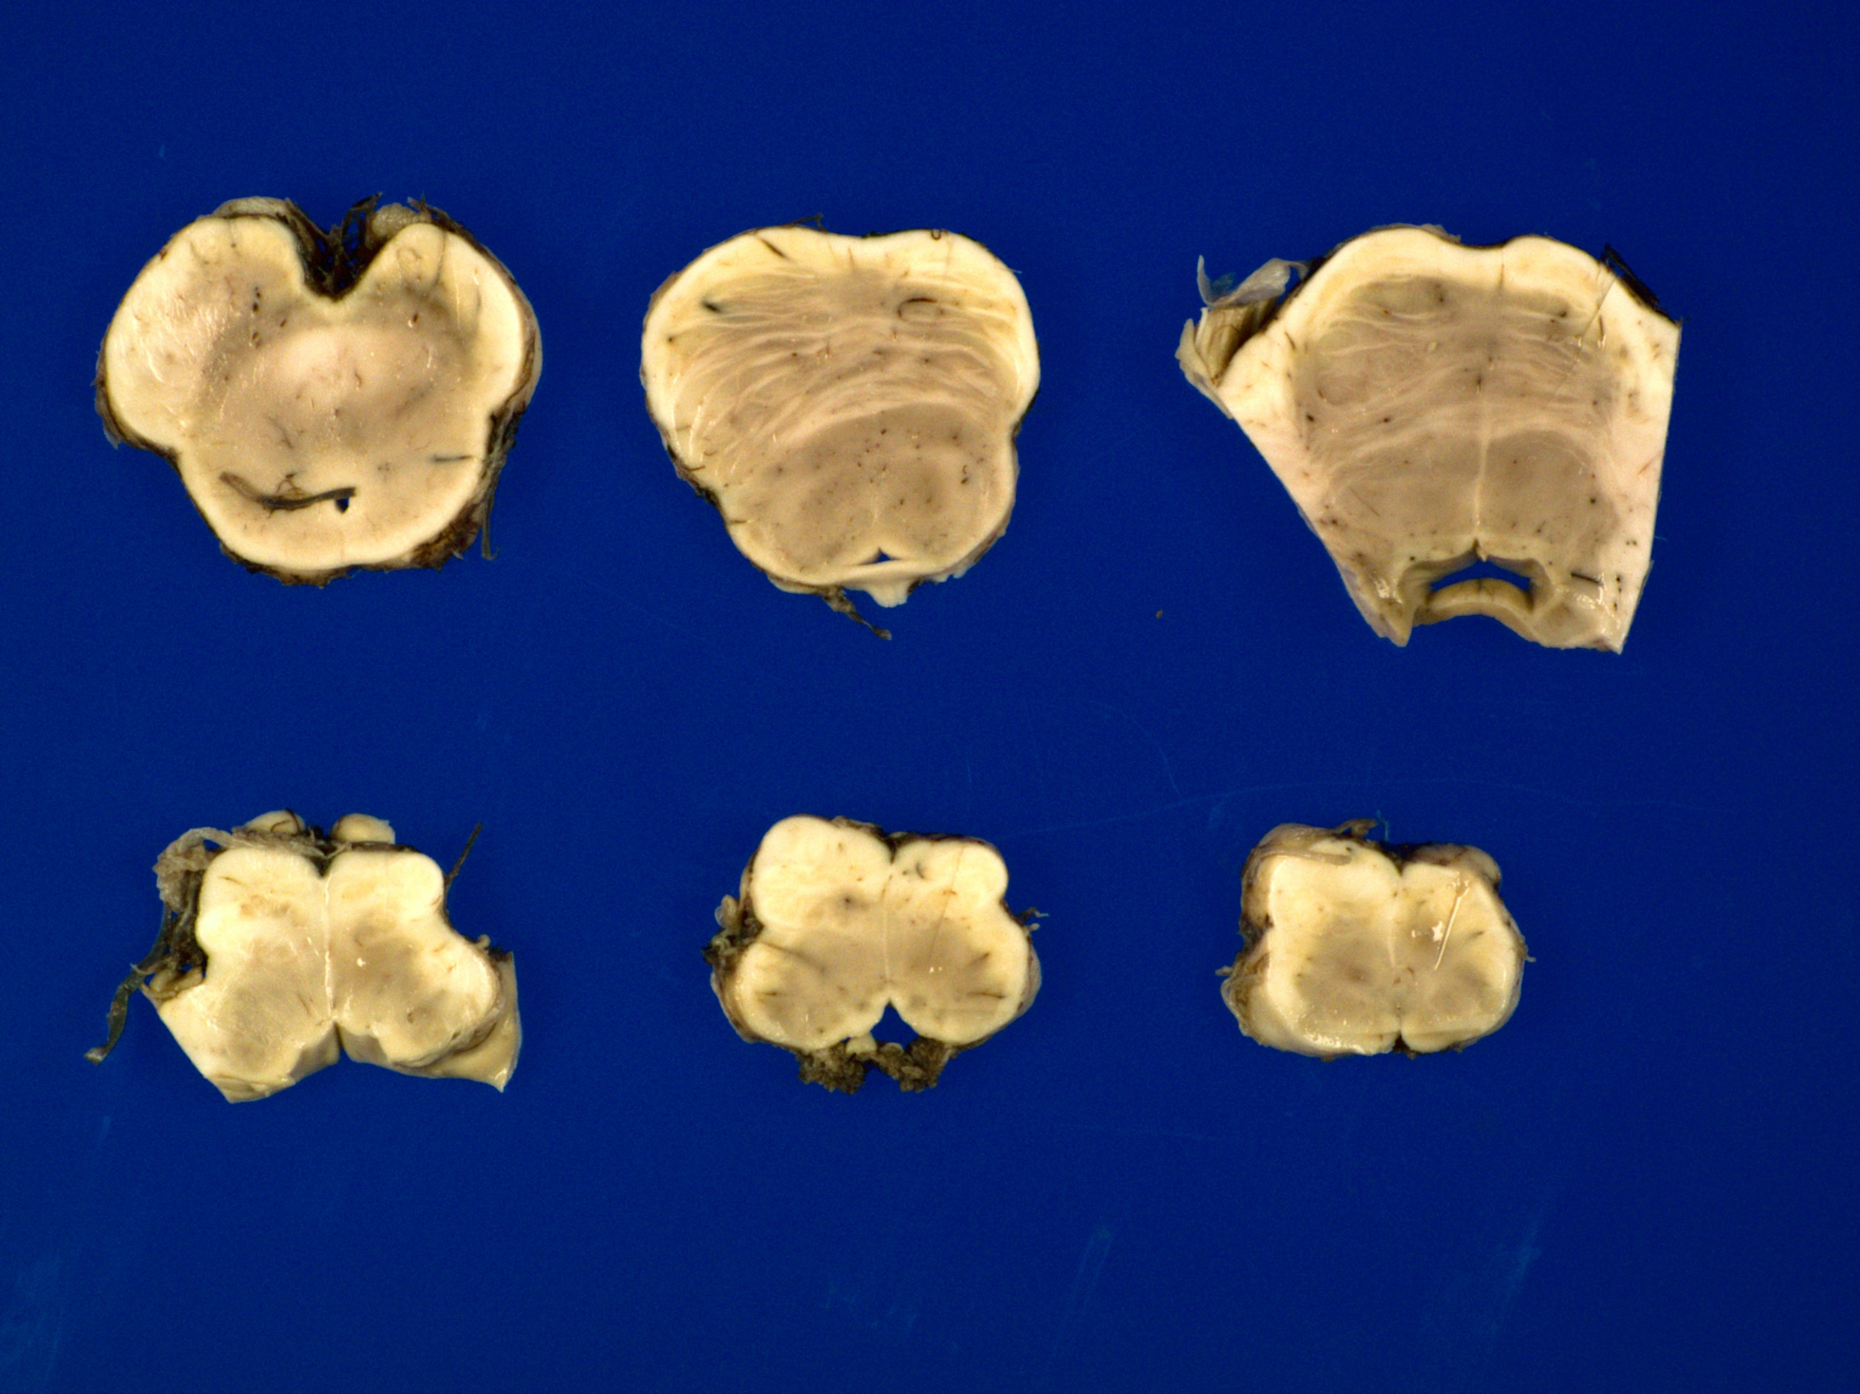
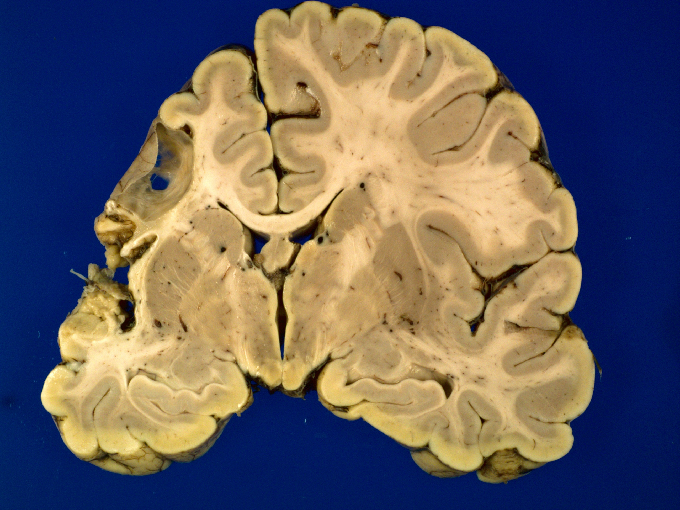
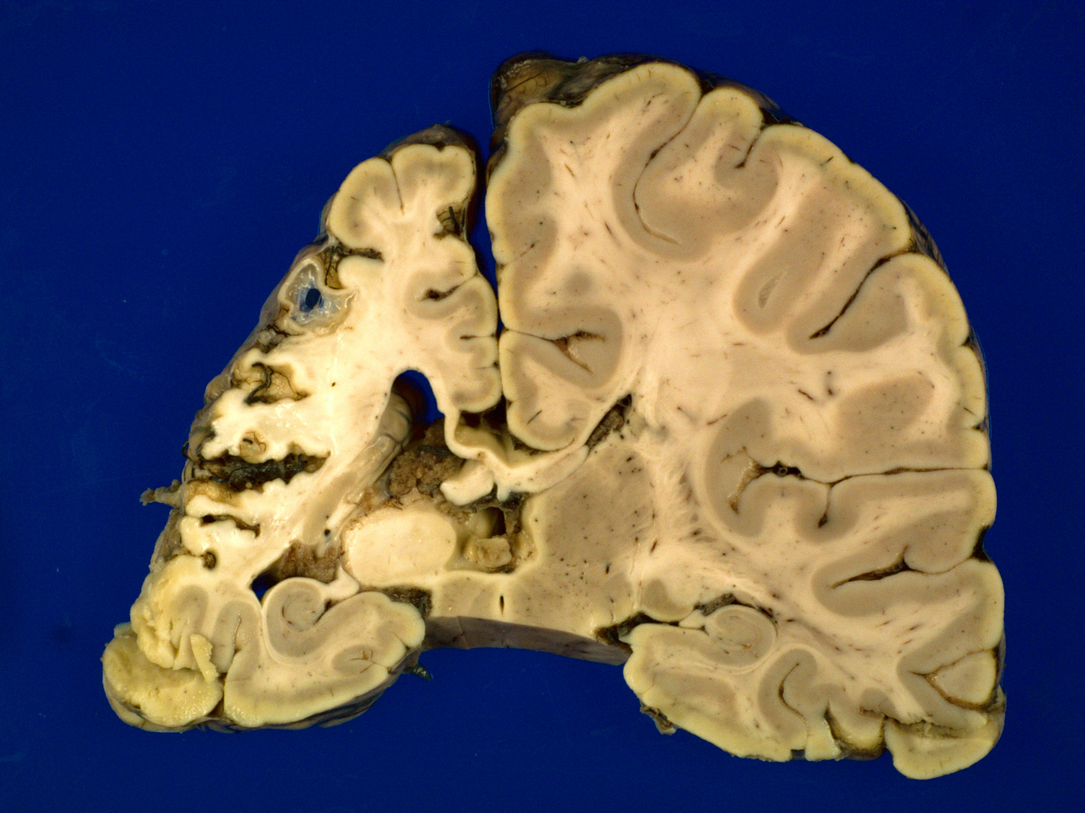
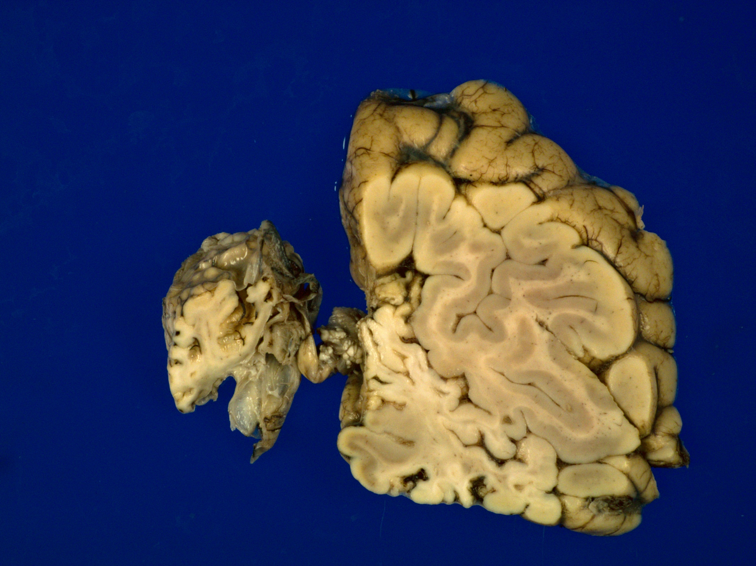

H&E left frontal
H&E medulla

Diagnosis? Multicystic encephalopathy with ulegyria, columnar cortical injury and atrophy of corticospinal tracts

Diagnosis? Meningioma

