Neuropathology Case

Children’s Hospital Conference, Friday July 17, 2015

14 yo male with flu-like symptoms and sinusitis; was found to have papilledema. No headache or neurological deficits.

T1 T2 Flair
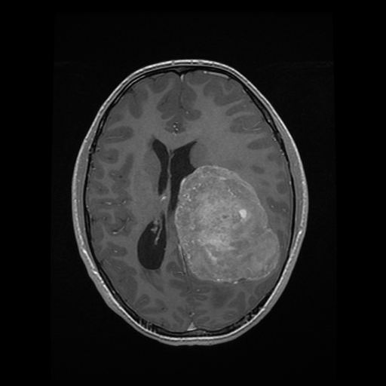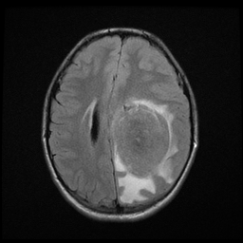
T1 + contrast
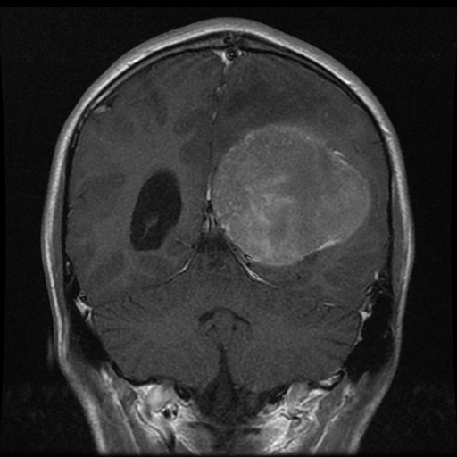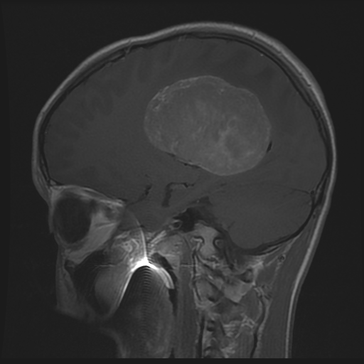
H&E slide at CHP

Diagnosis?

