Neuropathology Case

Children’s Hospital Conference
Friday July 13, 2012

5 year-old male with 8 wk h/o intermittent spells of vomiting associated with headache, abdominal pain, and lethargy. Evaluation revealed low cortisol and thyroid levels and the following MRI findings.

MRI T1 T2
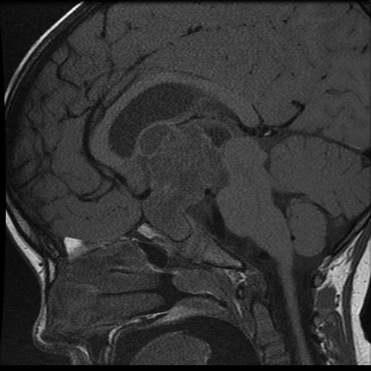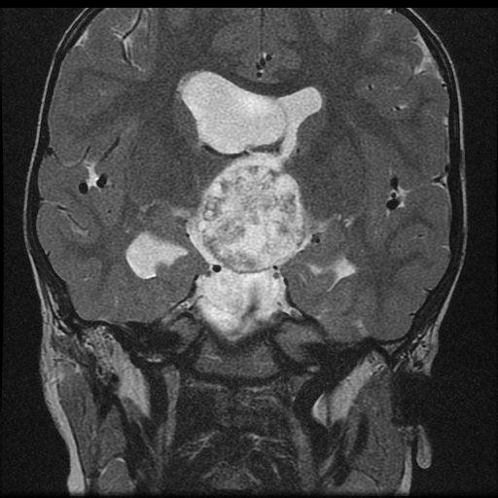

T1 + C
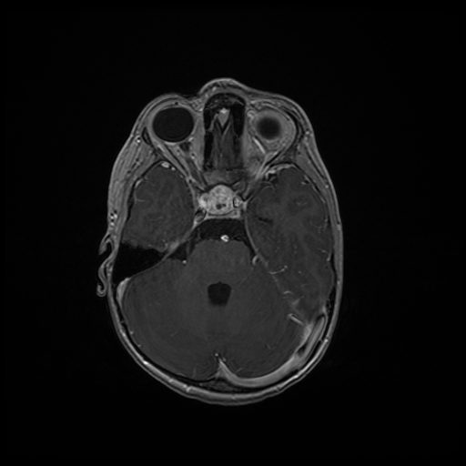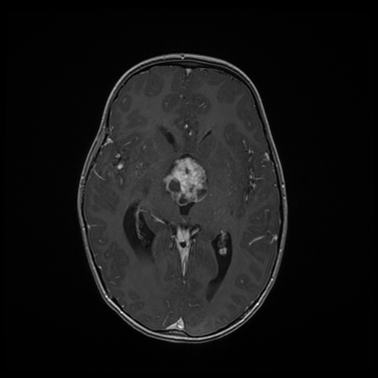

H&E

- Diagnosis?
- Describe changes in the tissue surrounding the tumor.

