CHILDREN’S HOSPITAL CONFERENCE CASE 6.19.2015

6 y/o male incidental finding on scans after bike crash induced epidural hematoma
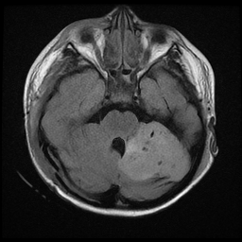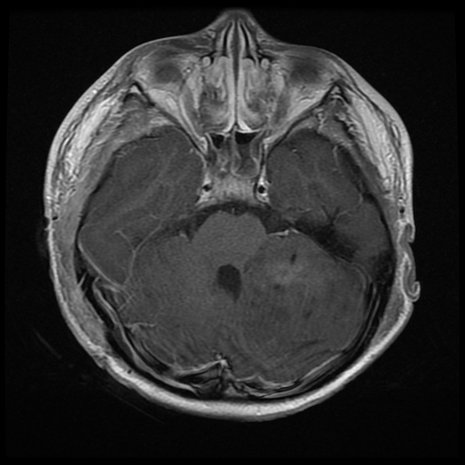
T2 Flair T1 with contrast

Surgical specimen:

