Neuropathology Case

Children’s Hospital Conference
Friday June 17, 2011

The brain is from a young adult female with an unspecified history of spina bifida surgery in early childhood who died due to complications of chronic renal failure. Below are gross images of incidental autopsy findings in the brain and lower cervical/upper thoracic spinal cord.
Normal
Patient
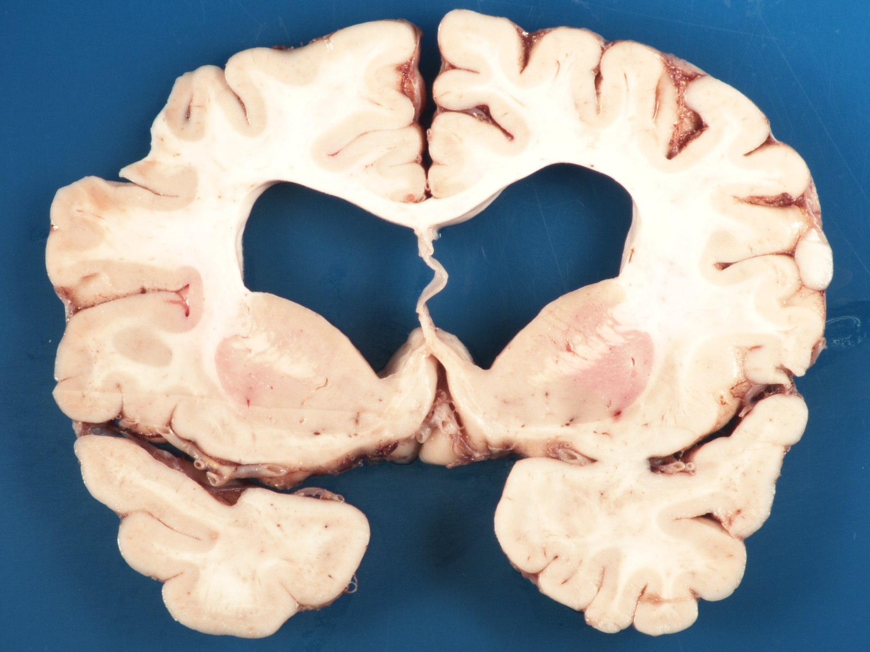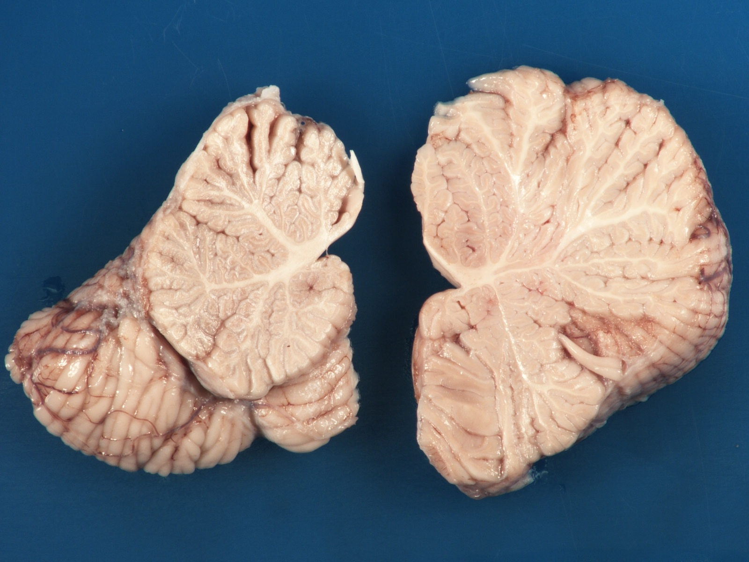

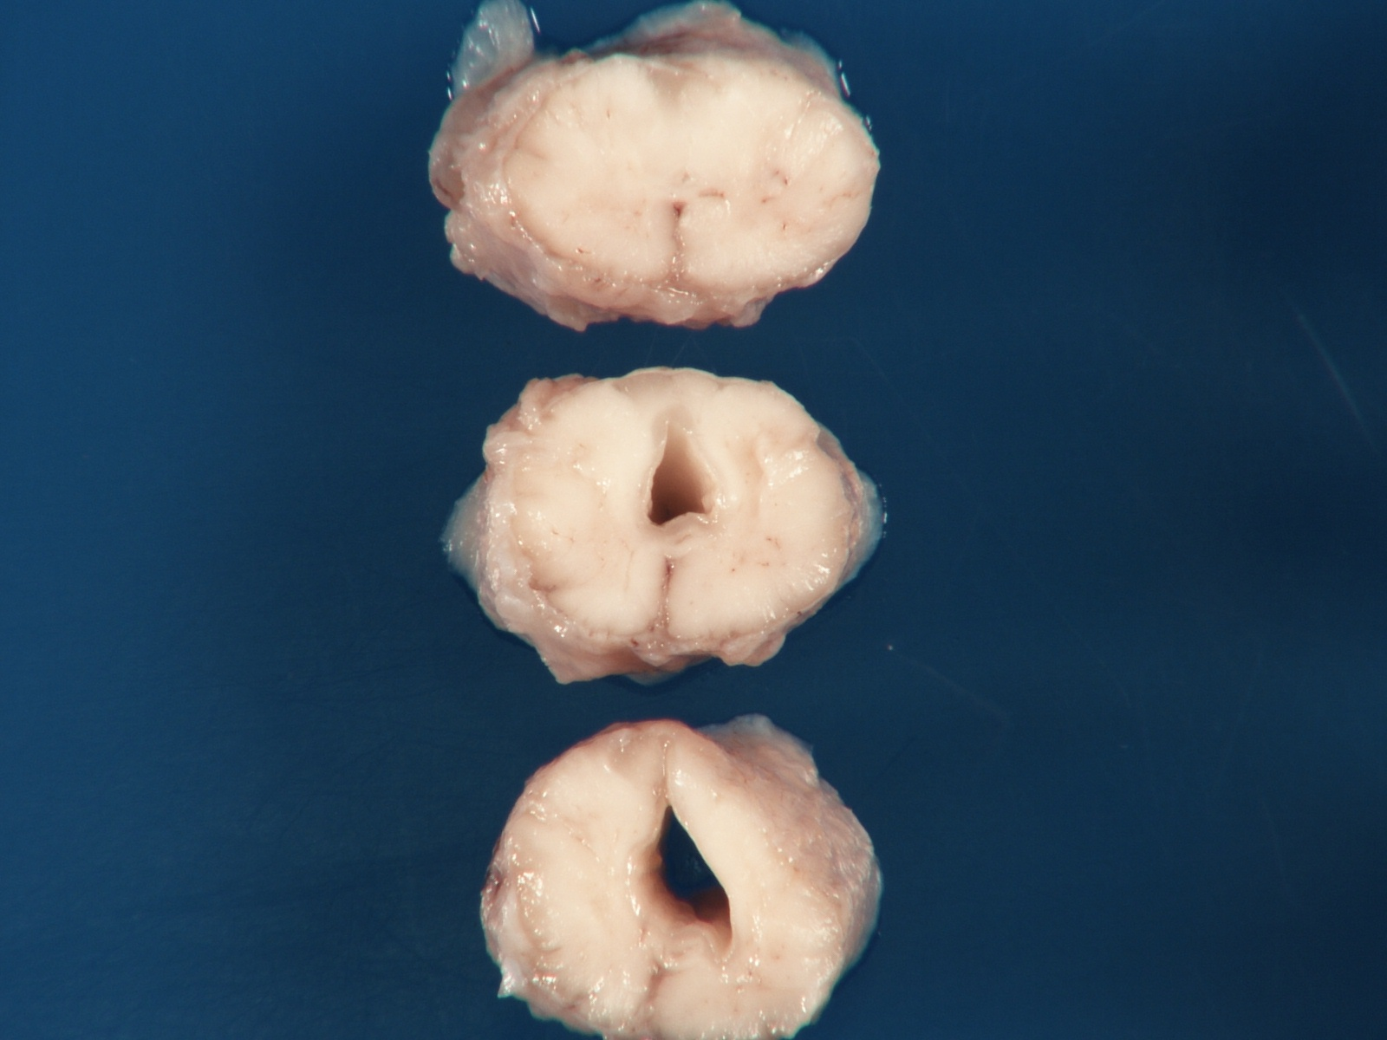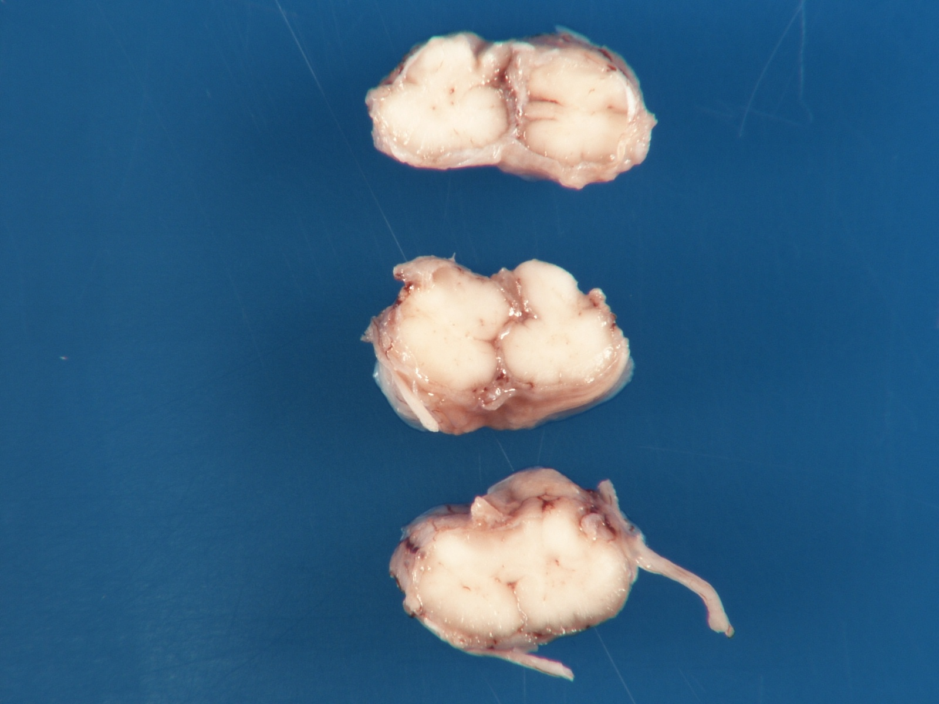
Upper thoracic
Lower cervical

H&E spinal cord lower cervical
H&E spinal cord upper thoracic

Diagnosis?

