Neuropathology Case

Children’s Hospital Conference
Friday May 30, 2014

12 yo male with 6 week history of headaches and increased sleepiness

T1 T2 flair
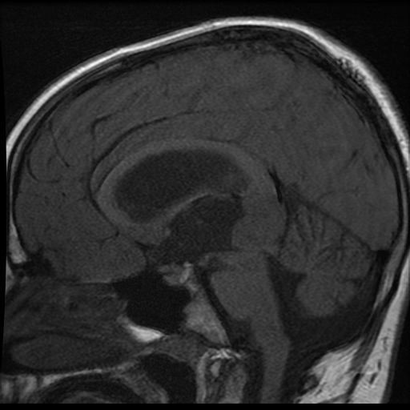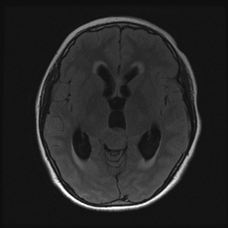

T1 + C
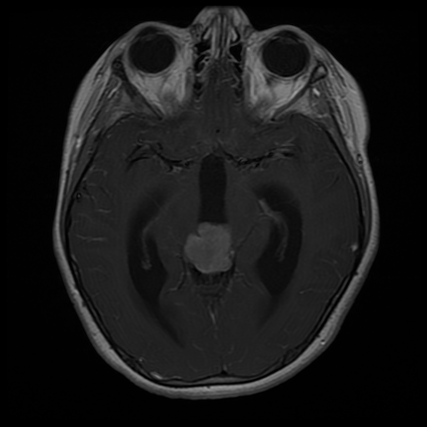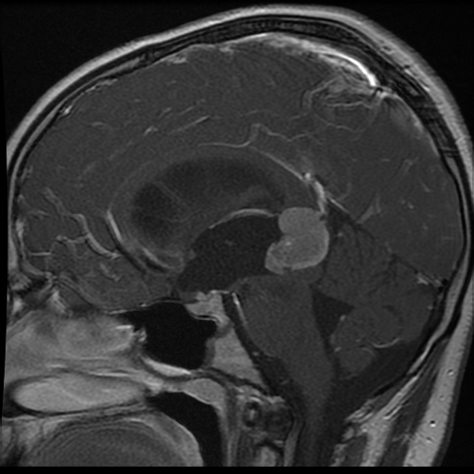

Intraoperative smear:
Smear

Diagnosis: Pineoblastoma

