CHILDREN’S HOSPITAL CONFERENCE CASE 5.20.2011

16 y/o female with 8 years of seizures beginning after a fall with head trauma. There is a family history of epilepsy. Recent mri for bifrontal headaches.
FLAIR
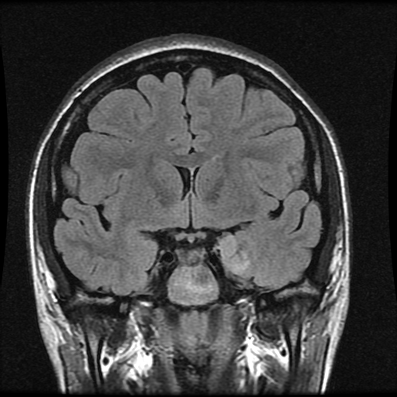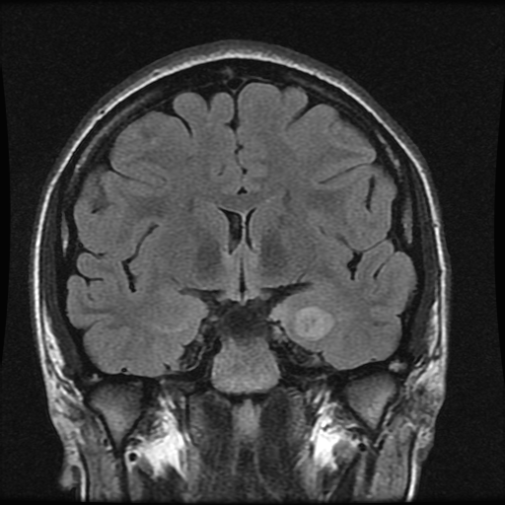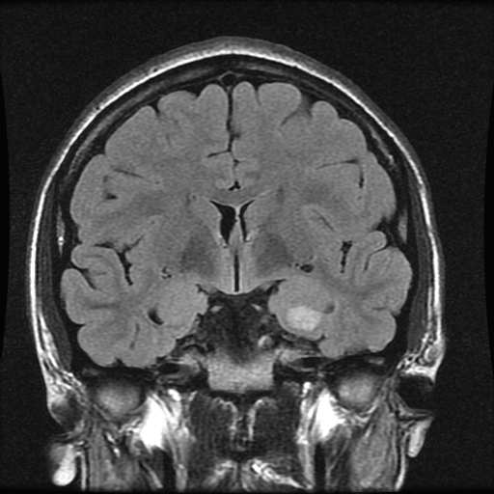

T1+C
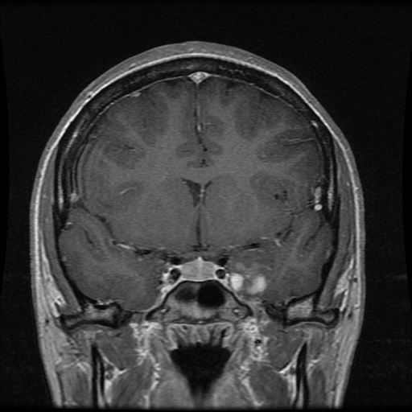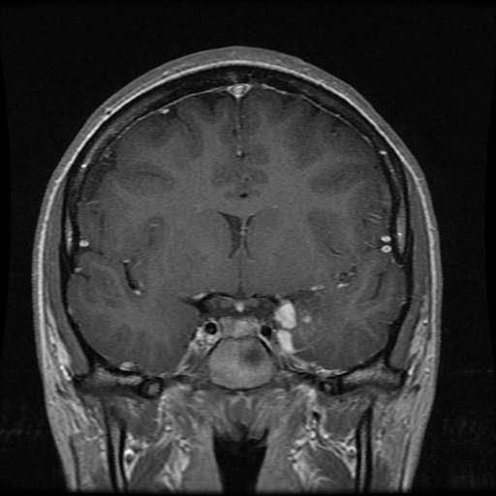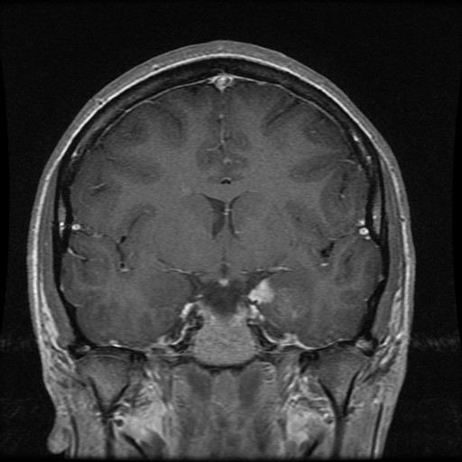

T2 Propeller
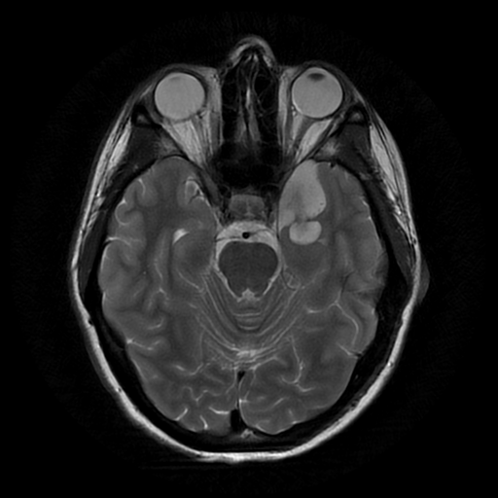
Describe the lesion. What is the clinical/radiologic differential? IntraOp and final Dx?
IntraOP smear: http://image.upmc.edu:8080/NeuroPathology/PediatricTumors/PediatricTumor2/PT.24A.svs/view.apml?
Paraffin Section:
H&E (Paraffin) - http://image.upmc.edu:8080/NeuroPathology/PediatricTumors/PediatricTumor2/PT.24B.svs/view.apml?
Synaptophysin Immuno:
http://image.upmc.edu:8080/NeuroPathology/PediatricTumors/PediatricTumor2/PT.24C.svs/view.apml

