CHILDREN’S HOSPITAL CONFERENCE CASE 5.12.2016

9 y/o female with two weeks of headaches, falls now with nausea vomiting and somnolence.

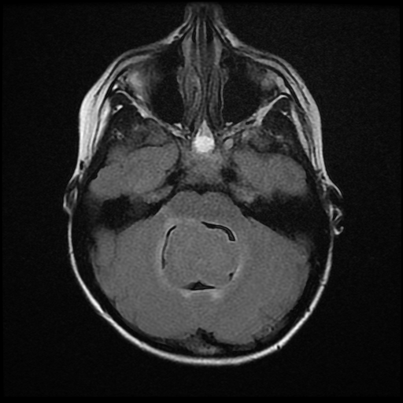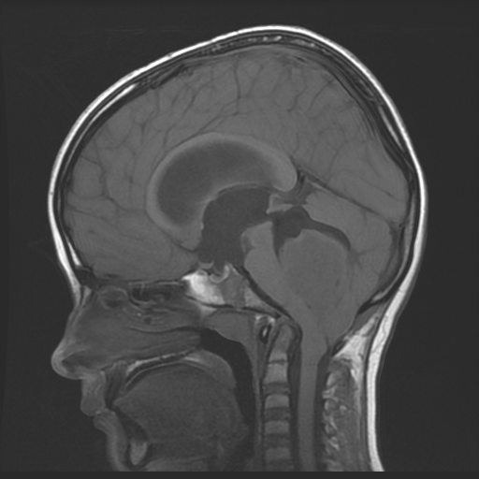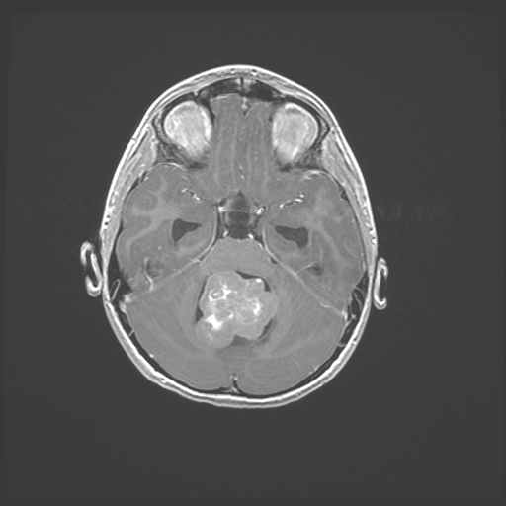
T2 Flair T1 T1 SPGR

Smear and HE will be put out.

