Neuropathology Case

Children’s Hospital Conference
Friday May 10, 2013

35 year-old female with primary generalized seizures since the age of 14. The patient has 1-2 seizures during her menstrual cycle. Medications include Diamox (acetazolamide) and Dilantin (phenytoin). Neurologic examination at last neurology appointment on 4/4/12 showed fluent, but limited spontaneous speech, no dysarthria, normal coordination and normal gait. On 1/30/2013, patient was found dead on bedroom floor.

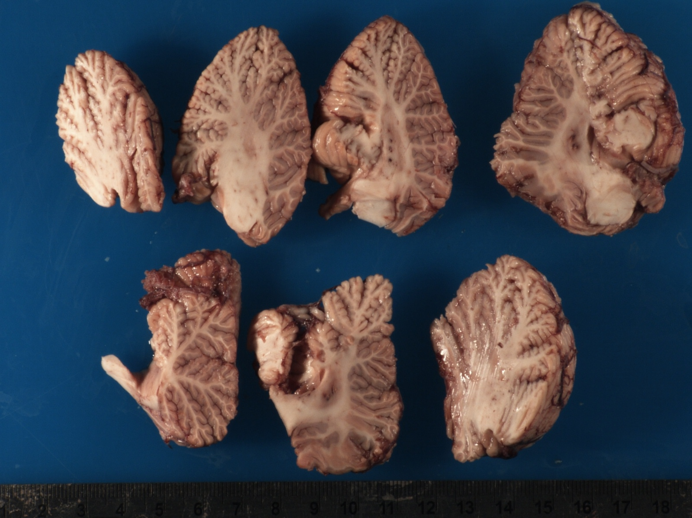

H&E

Diagnosis?

