CHILDREN’S HOSPITAL CONFERENCE CASE 3.26.2010

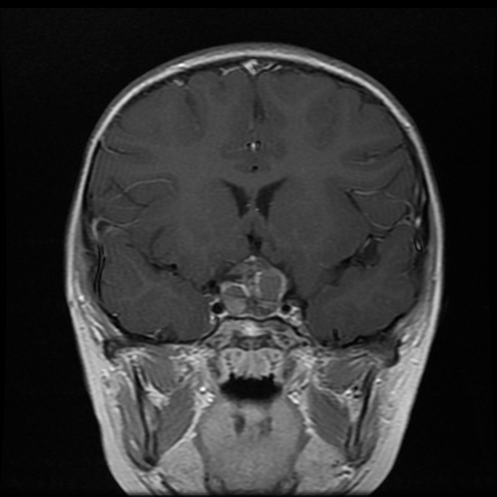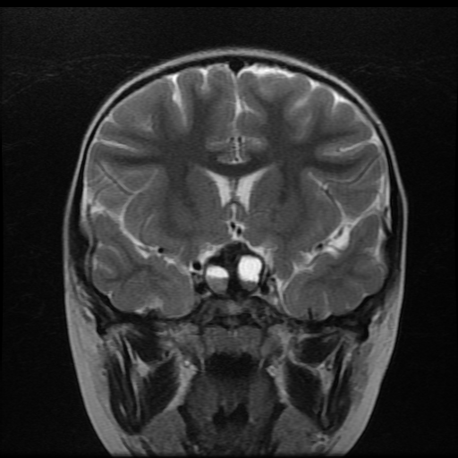
T1+C T2
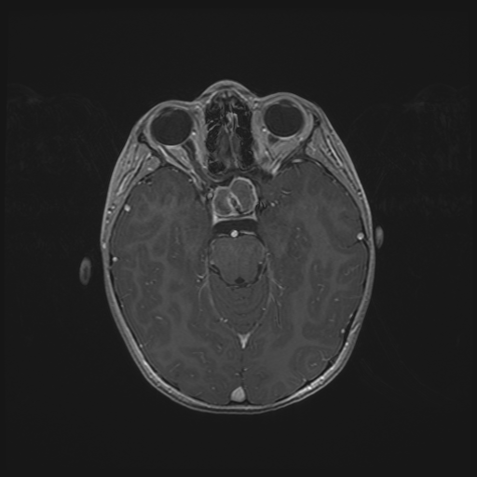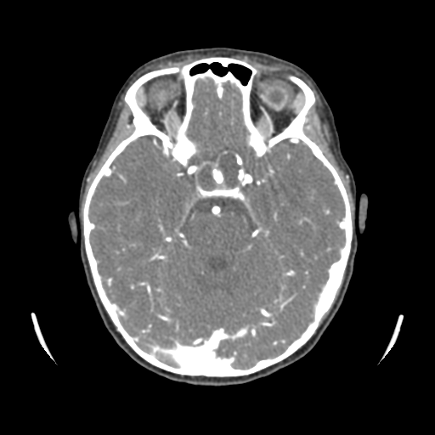
T1+C CT +C

9 y/o Female undergoing endoscopic endonasal approach resection of a presumed craniopharyngioma.
Describe the location and characteristics of the lesion?
What else could be in the differential diagnosis?

INTRAOPERATIVE SMEARS
Asked to confirm preop diagnostic impression.
http://image.upmc.edu:8080/NeuroPathology/NonGlialTumors/NonGlialTumors2/NG.115C.svs/view.apml?

ANSWER
CRANIOPHARYNGIOMA WITH XANTHOGRANULAOMATOUS REACTION AND OSSIFYING KERATIN DEBRIS.

http://image.upmc.edu:8080/NeuroPathology/NonGlialTumors/NonGlialTumors2/NG.115B.svs/view.apml?
http://image.upmc.edu:8080/NeuroPathology/NonGlialTumors/NonGlialTumors2/NG.115A.svs/view.apml?

