CH Path. Friday Feb 8, 2013
14 month old boy with hydrocephalus.

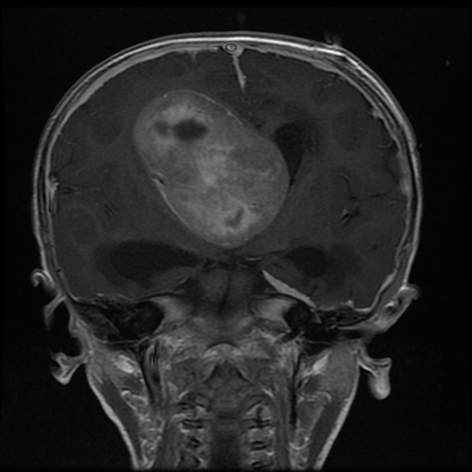

What is the differential diagnosis of an intraventricular tumor in a very young child.

Answer:

Differential by radiology includes: choroid plexus tumor, neurocytoma, pilocytic astrocytoma, glioblastoma, ependymoma, PNET, Atypical teratoid/rhabdoid tumor, subependymal giant cell tumor, subependymoma

See images in CoPath chs13-732
It is a small blue cell tumor with high grade features that stains for synaptophysin and N-CAM, but has no loss of INI-1 staining. EMA and cytokeratin are negative. GFAP is positive in a few cells.

FINAL DIAGNOSIS:
PRIMITIVE NEUROECTODERMAL TUMOR (PNET), or cerebral PNET

