CH Path. Friday Feb 8, 2013
14 month old boy with hydrocephalus.

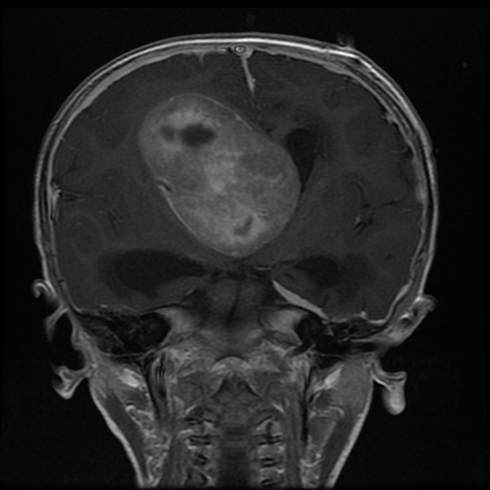

What is the differential diagnosis of an intraventricular tumor in a very young child.

