Neuropathology case (C.A. Wiley)
Children’s Hospital Friday December 5th 2014 8:30 AM conference

15 year old with a 6 month history of headaches and recently observed MRI abnormality

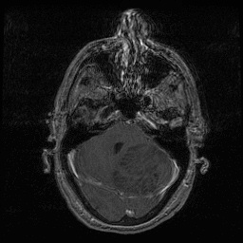
T2 T1 + contrast
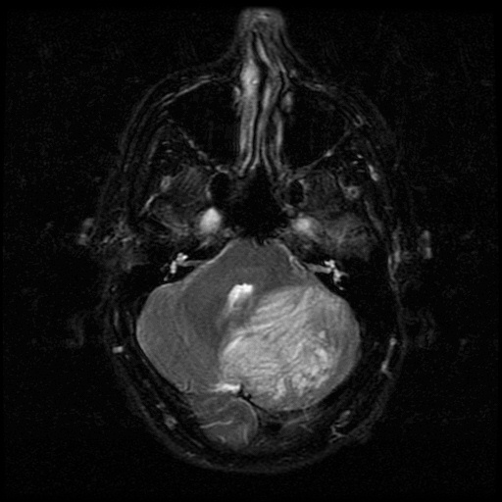

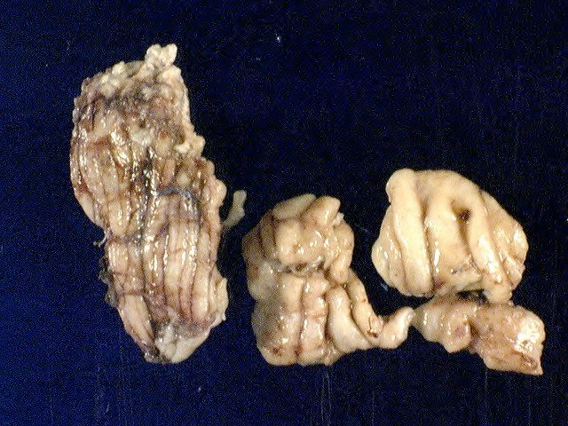
Gross image

Perilesional Lesion

H&E Slide

Diagnosis: Dysplastic gangliocytoma (Lhermitte-Duclos disease)

