Neuropathology Case

Children’s Hospital Conference
Friday November 18, 2011

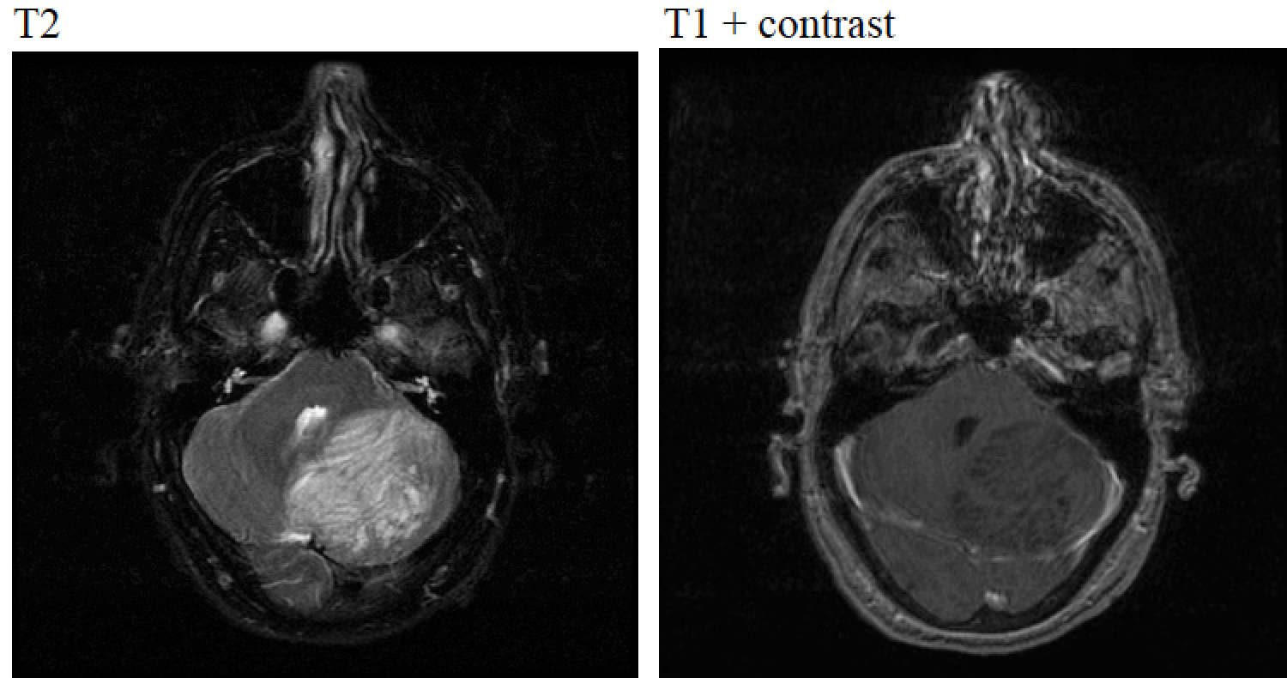

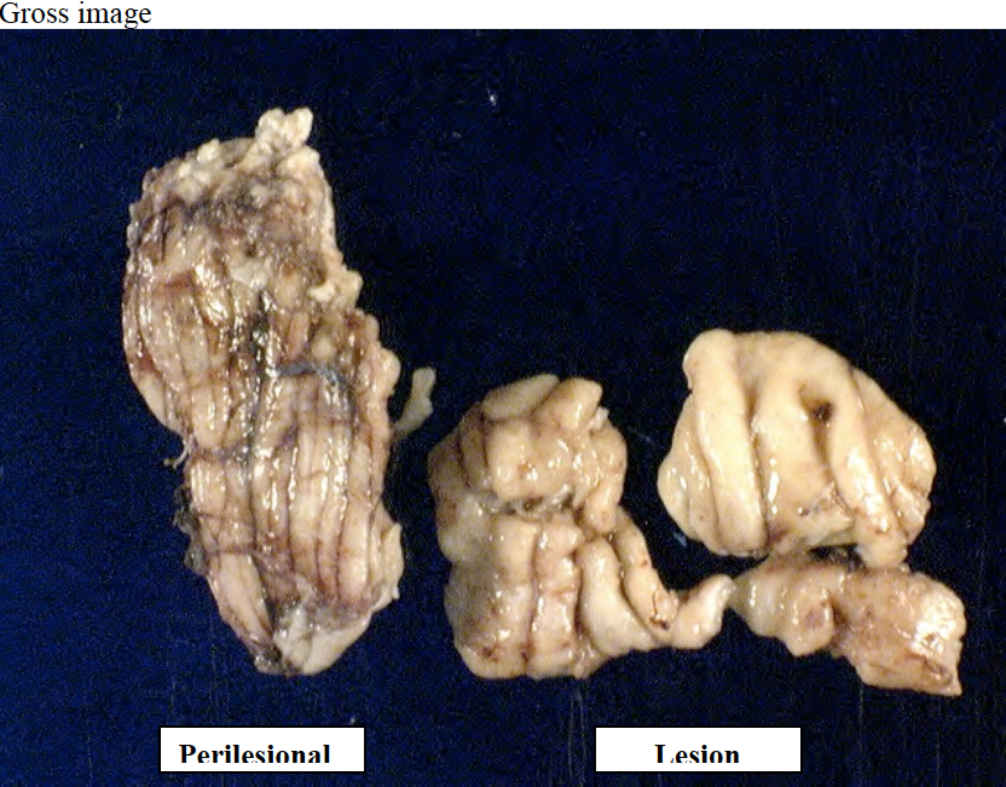
H&E slide

