CHILDREN’S HOSPITAL NP CONFERENCE CASE
November 1, 2013 Clayton Wiley

3 year old female with recent history of N&V
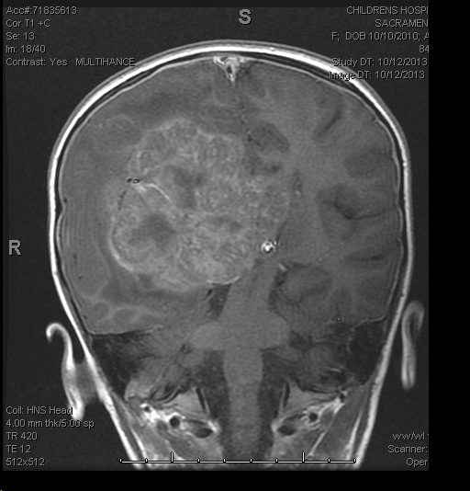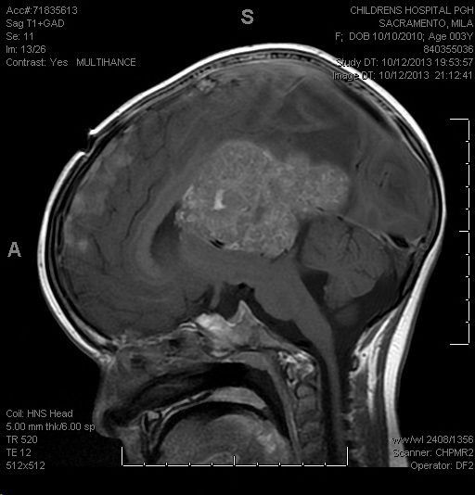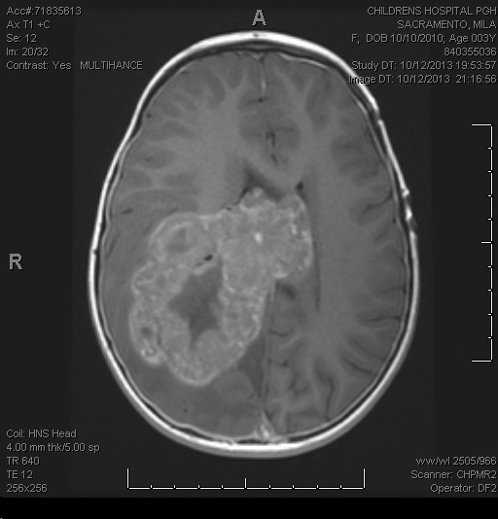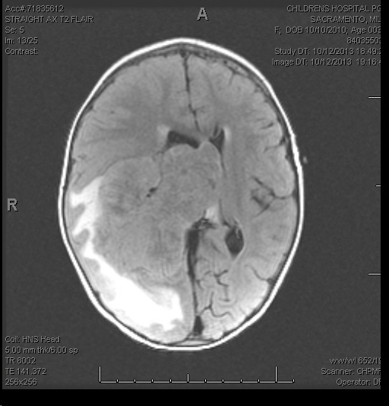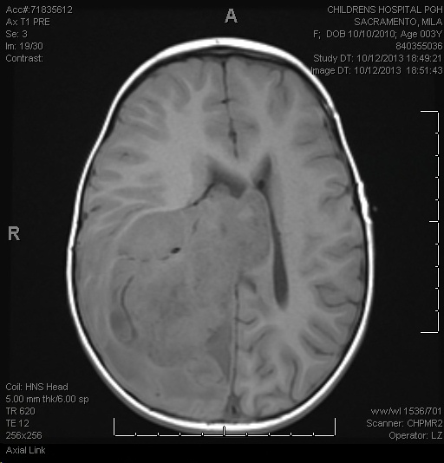
Intra Op H&E

What is you introp DX?
What stains do you want to order up front?

Answer:
Choroid Plexus Carcinoma

Permanent H&E
Permanent Prealbumin (transthyretin)
Permanent Ki67
Permanent GFAP
Permanent Cam5.2
Permanent Ini1
Permanent Myogenin
Permanent Vimentin

