CHILDREN’S HOSPITAL CONFERENCE CASE 10.23.2015

6 y/o female with two weeks of headaches, falls now with nausea vomiting and somnolence.

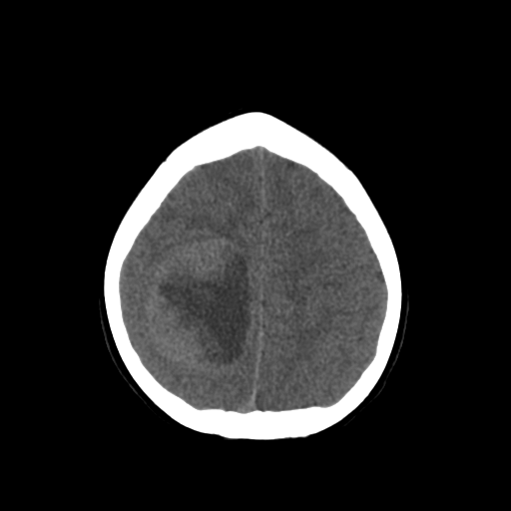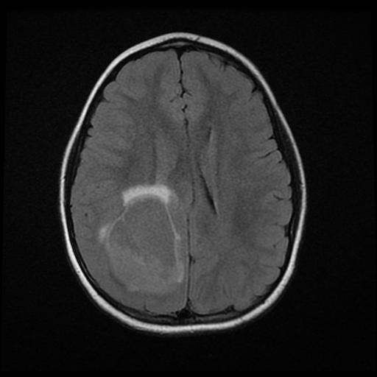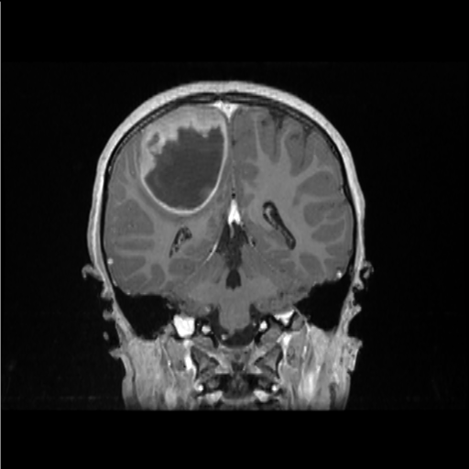
CT T2 Flair SPGR
T1 with contrast

Smear and HE will be put out.

