Neuropathology Case

Children’s Hospital Conference, Friday October 16, 2015

26 yo with a clinical history of repaired Tetralogy of Fallot, severe cognitive disability (non-verbal) and seizures. She had complex genetic abnormalities with partial trisomy 3 and monosomy 1q. She was admitted with status epilepticus and died from aspiration pneumonia. Brain weight 470 grams.

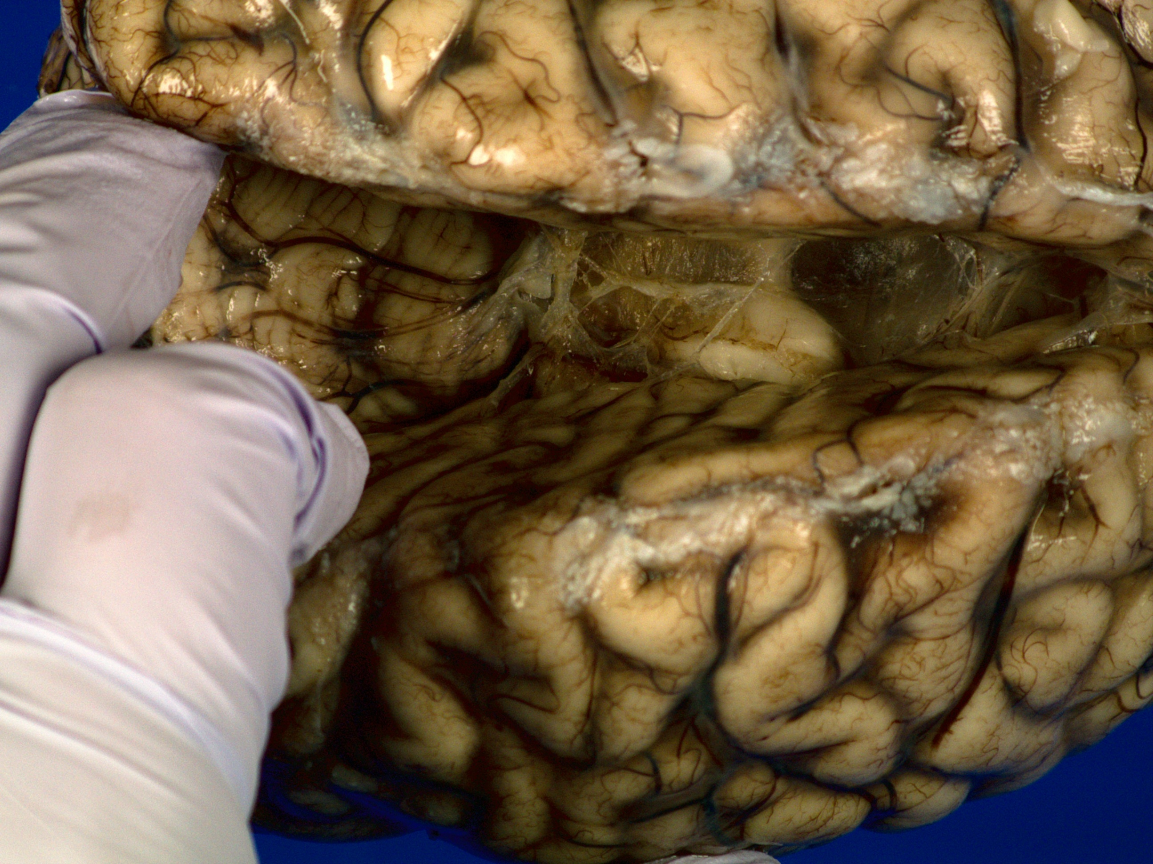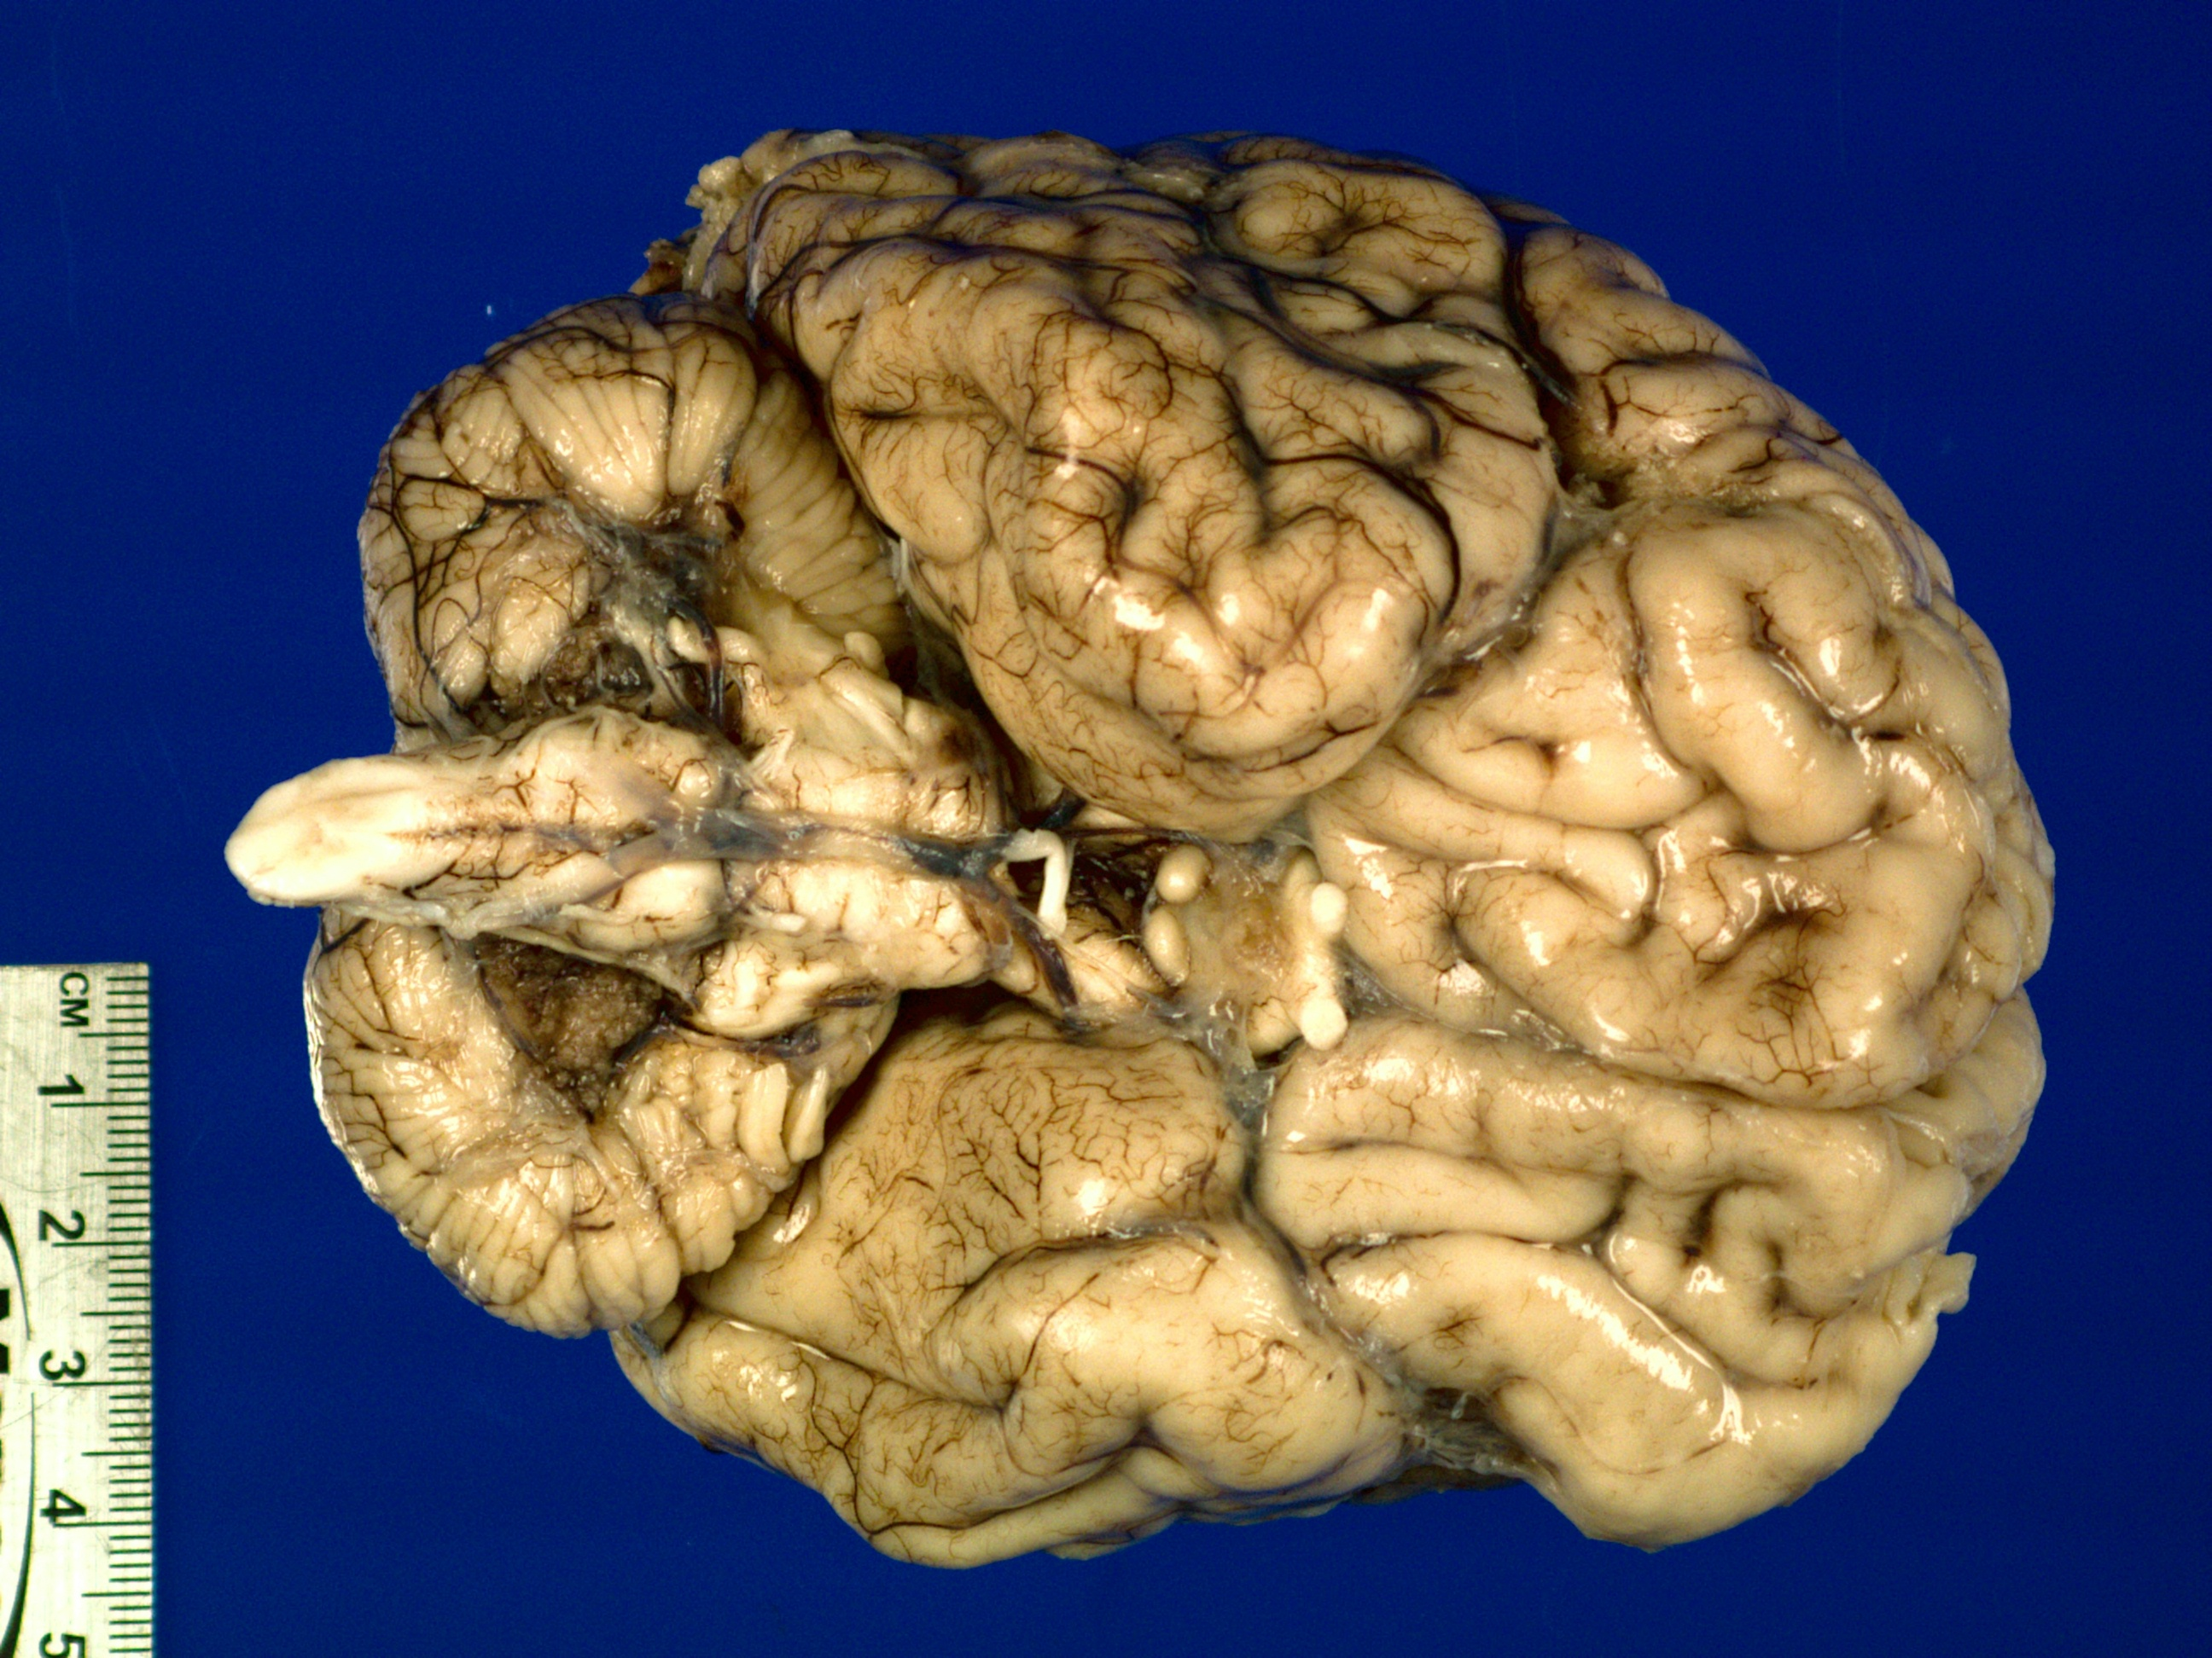

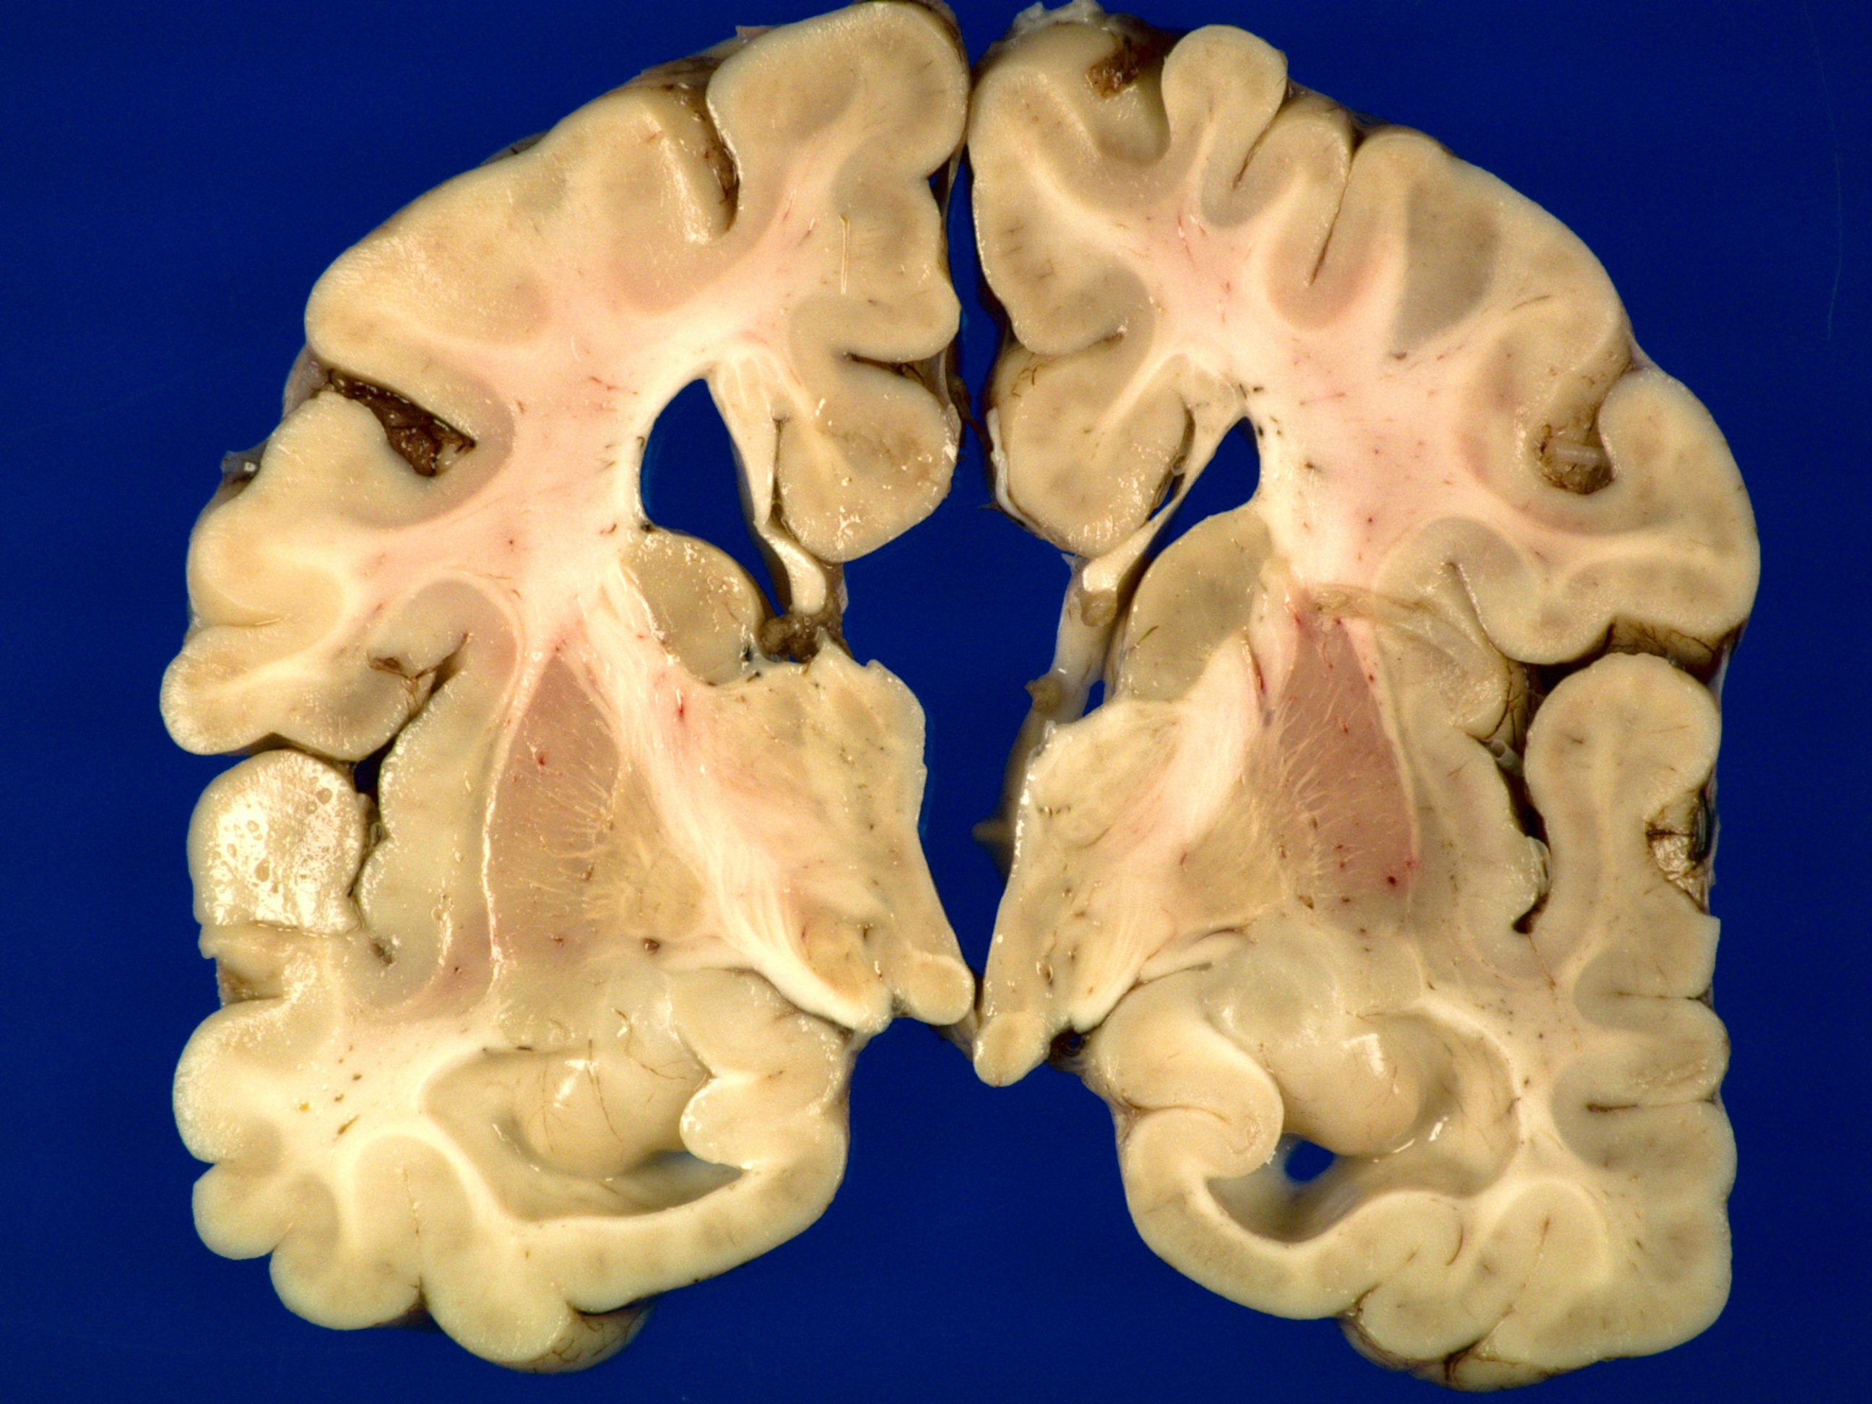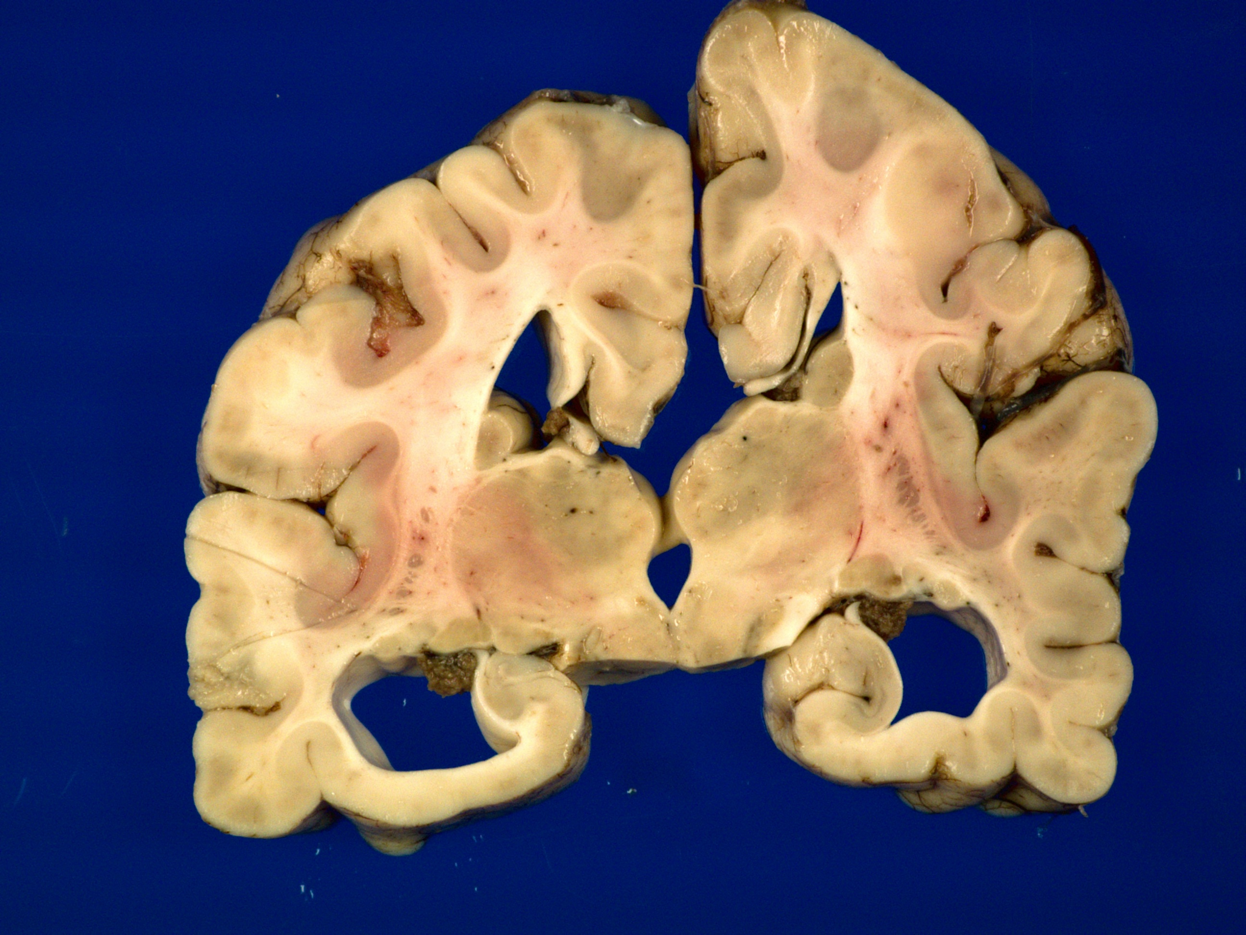

H&E

Diagnoses: Agenesis of corpus callosum
Microcephaly
Olfactory aplasia

