Neuropathology case (C.A. Wiley)

Children’s Hospital Friday January 21st, 2011 8 AM conference

5 month old female with year history of intra-uterine hydrocephalus, large head at birth and left zygomatic mass.

Head ultrasound at birth

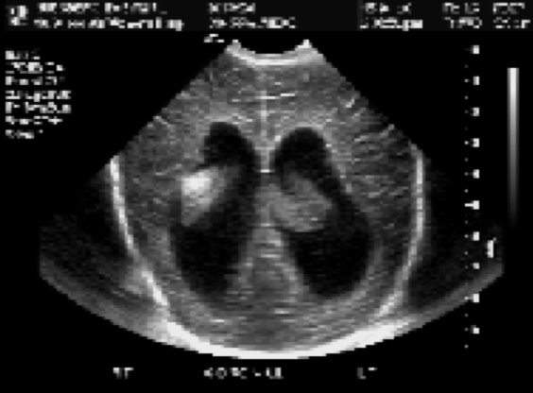

Head ultrasound at 1 month

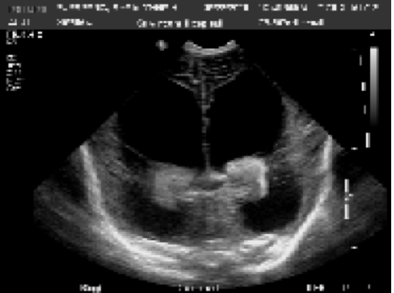

MRI T1 w/o Contrast

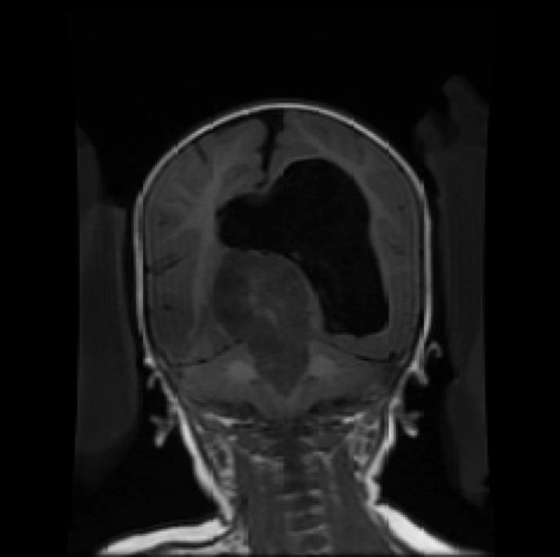

MRI wC



CT Zygomatic mass



Describe radiological findings

Patient underwent decompression of hydrocephalus and this tissue came out with the needle

[H&E](http://image.upmc.edu:8080/NeuroPathology/GlialTumors/GlialTumor2/GT.90/GT.90A.svs/view.apml?)

Your diagnosis?

Zygomatic mass was then biopsied

[H&E](http://image.upmc.edu:8080/NeuroPathology/GlialTumors/GlialTumor2/GT.90/GT.90B.svs/view.apml?)

Your diagnosis?

What additional studies would you perform?