Neuropathology Case

Children’s Hospital Friday January 14, 2011

52 year old female with unknown past medical history presented to the ED, transferred from an outside hospital, with a questionable intracerebral bleed near the pineal gland. The patient had altered mental status upon presentation. Further workup was concerning for a meningoencephalitis secondary to right ear infection; however, MRI imaging showed essentially normal brain parenchyma and no convincing evidence of leptomeningeal enhancement.

MRI T1 coronal w/C
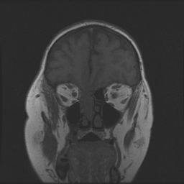

MRI T1 coronal +c
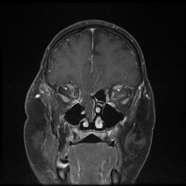

Smear
Diagnosis?

