CH Path. Friday Jan 11, 2013
12 month old girl with hydrocephalus.

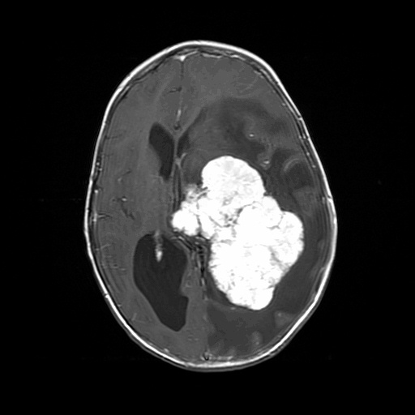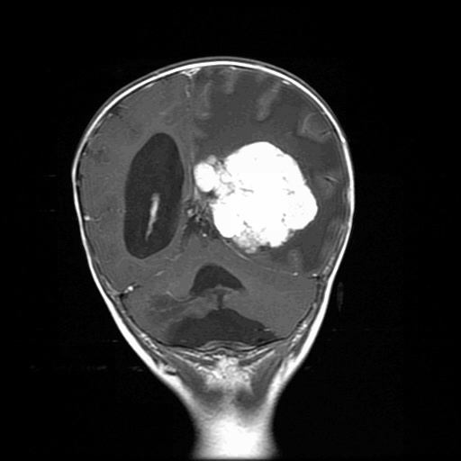

What is the differential diagnosis of an intraventricular tumor in a very young child.

Answer:

Differential by radiology includes: choroid plexus tumor, neurocytoma, pilocytic astrocytoma, glioblastoma, ependymoma, PNET, Atypical teratoid/rhabdoid tumor, subependymal giant cell tumor, subependymoma

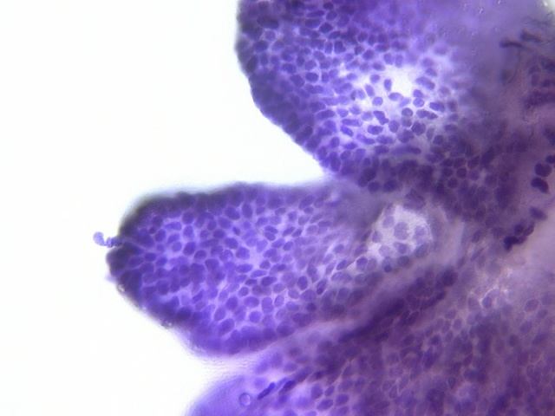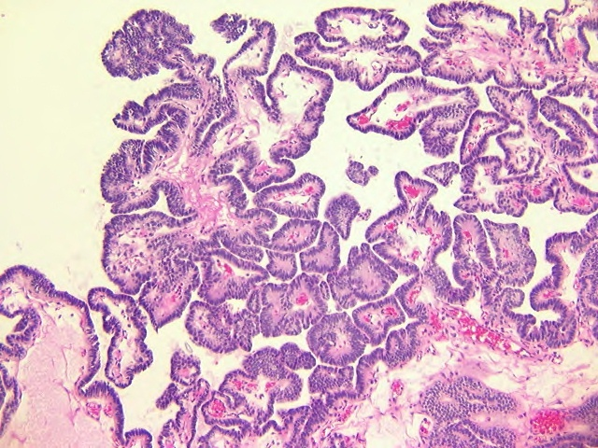

FINAL DIAGNOSIS:
CHOROID PLEXUS PAPILLOMA

Where does this kind of tumor occur in adults?

ANS: Fourth ventricle

