CH Path. Friday Jan 11, 2013
12 month old girl with hydrocephalus.

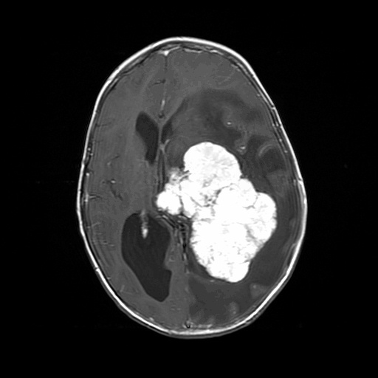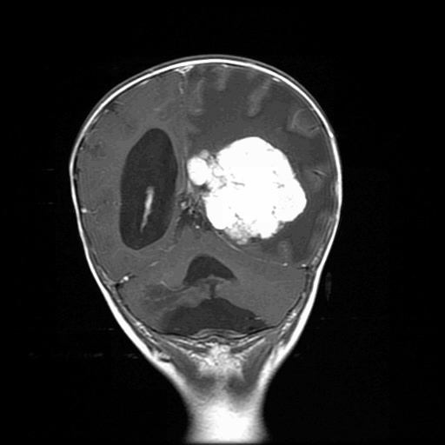

What is the differential diagnosis of an intraventricular tumor in a very young child.

