Neuropathology Case 3

Children’s Hospital Conference
Friday August 26, 2016

18 year old male with new onset of seizures

T1 T1
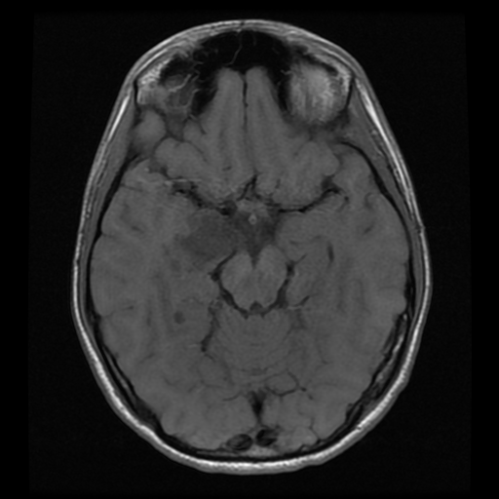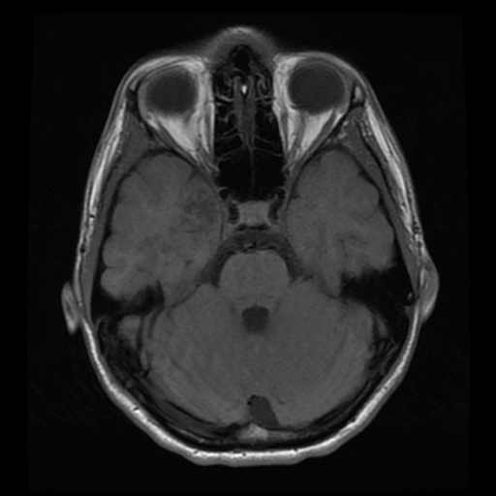

T2 flair T1+contrast
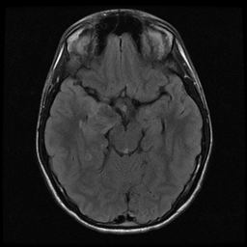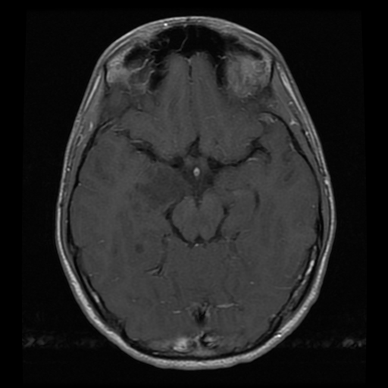

H&E H&E H&E
NeuN IDH1 Synaptophysin Ki-67

Diagnosis?

