Neuropathology Case 1

Children’s Hospital Conference
Friday August 26, 2016

9 year old male with 3 week history of headaches, vomiting and left-side sensory difficulties

T1 T1+contrast
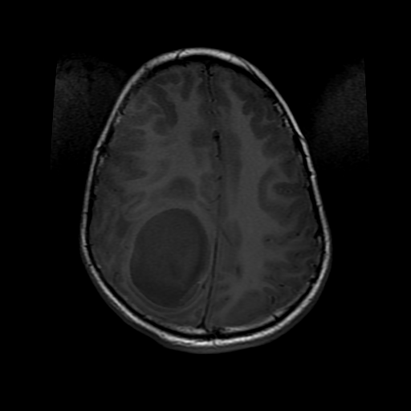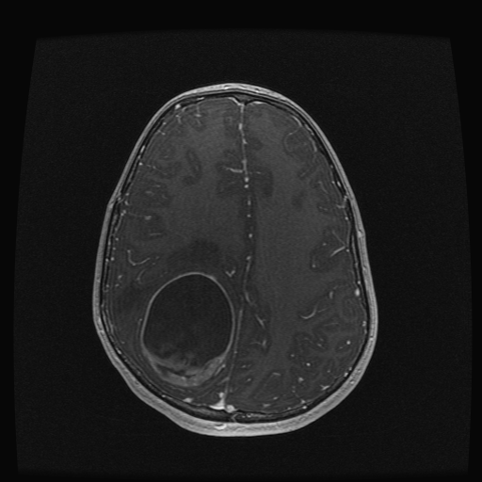

T2 T2
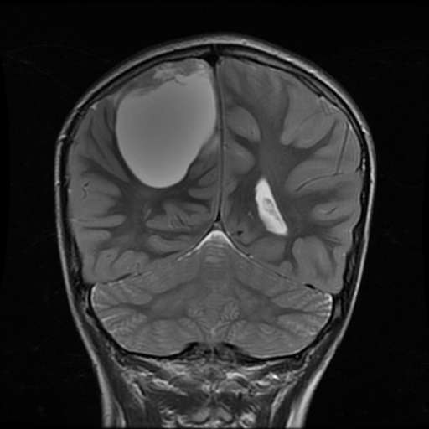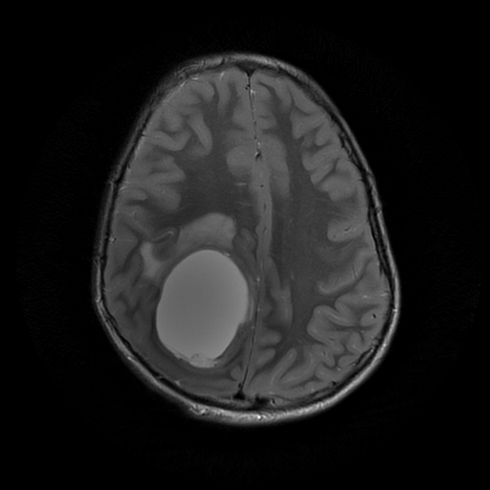

H&E

Diagnosis? Molecular considerations? Ependymoma, RelA fusion positive

